Message in a Bottle: Archived DNA Reveals Marine Heatwave-Associated Shifts in Fish Assemblages

Zachary Gold1,2, Ryan P. Kelly3, Andrew Olaf Shelton2, Andrew Thompson4, Kelly D. Goodwin5, Ramon Gallego2, Kim Parsons2, Luke R. Thompson5,6, Dovi Kacev7, Paul H. Barber8

1 Cooperative Institute for Climate, Ocean, & Ecosystem Studies, UW, Seattle, WA

2 Northwest Fisheries Science Center, NMFS/NOAA, Seattle, WA

3 School of Marine and Environmental Affairs, UW, Seattle, WA

4 Southwest Fisheries Science Center, NMFS/NOAA, La Jolla, CA

5 Ocean Chemistry and Ecosystems Division, Atlantic Oceanographic and Meteorological Laboratory, Miami, FL

6 Northern Gulf Institute, Mississippi State University, Mississippi State, MS

7 Scripps Institution of Oceanography, UCSD, La Jolla

8 Department of Ecology and Evolutionary Biology, UCLA, Los Angeles, CA

**Abstract**

Marine heatwaves can drive large-scale shifts in marine ecosystems, but their impacts can be difficult to study from a a species assemblage perspective. Here, we combine DNA sequences derived from the ethanol of a 23-year longitudinal sample collection with microscopy-derived ichthyoplankton identification to demonstrate tropicalization of fish assemblages in the California Current Large Marine Ecosystem during and after the 2014-16 unprecedently large Pacific marine heatwave. Our quantitative model estimated assemblage composition and abundance to reveal increases in southern, mesopelagic species associated with declines in important temperate fisheries targets (e.g. North Pacific Hake (*Merluccius productus*) and Pacific sardine (*Sardinops sagax*)). We observed novel assemblages of tropical mesopelagic fishes and temperate species (e.g. northern anchovy, *Engraulis mordax*) even after the return to average water temperatures. Overall, the integrated dataset captured temporal assemblage dynamics of 56 fishes including important temperate marine indicator species that lack morphologically distinguishing characteristics. The technique of jointly modeling morphological and molecular data from ethanol-derived samples opens the door to reconstructing the historical dynamics of assemblages from modern and archived samples worldwide.

**Introduction**

Climate-induced marine heatwaves (MHWs) are increasing in frequency and severity with far-reaching consequences in marine ecosystems (*1*) ranging from severe organismal stress to cascading ecosystem effects (*2*). Notable recent examples include repeated bleaching events across the Great Barrier Reef (2016, 2017, 2020) (*3*) and near-total kelp deforestation in Northern California, USA (2016-19) (*4*). These marine heatwaves precipitated drastic, unprecedented changes in dominant foundational species across hundreds of thousands of square kilometers of shallow, coastal ecosystems.

The impacts of such large environmentally driven disturbances on on coastal marine ecosystems can be ecologically and economically significant (*5*–*7*). In the 1940s, the dramatic collapse of Pacific Sardine (*Sardinops sagax*) disrupted marine foodwebs, causing broad-scale, negative socio-economic impacts across the Northeast Pacific (*8*–*10*). To better understand the processes driving these complex marine ecosystem dynamics and to avert similar fisheries collapses within the California Current Large Marine Ecosystem (CCLME), the California Cooperative Oceanic Fisheries Investigations (CalCOFI) was formed in 1949. CalCOFI has continuously conducted systematic fisheries-independent surveys of the southern CCLME from 1951 until present (*11*, *12*), focusing on monitoring larval fish assemblages, as larval fish dynamics are a key predictor of ecosystem health and function (*5*, *12*, *13*).

Larval fish abundances help to characterize the state of marine ecosystems as they track spawning-stock biomass (*14*). Over 70 years of CalCOFI research has documented decadal and annual changes in fish assemblages in response to environmental conditions, identifying major shifts in response to Pacific Decadal Oscillations and El Niño Southern Oscillations (*12*, *15*–*17*). These decadal and annual changes in ichthyoplankton dynamics are superimposed over the strong biogeographic assemblage associations with distinct water mass characteristics within the Southern California Bight (*17*). Importantly, ichthyoplankton assemblages differ between the cold and fresher California Current; warm and saltier California Counter Current and Central Pacific water mass; as well as upwelling conditions across the continental shelf (*11*, *13*, *18*, *19*). Importantly, periods of elevated temperatures were historically associated with higher abundances of southern mesopelagic species and Pacific Sardine while cold periods were associated with higher abundances of northern mesopelagics and Northern Anchovy (*Engraulis mordax*) (*10*, *20*). These critical insights into forage fish community dynamics across decadal climatic regime shifts are vital to understanding the effects of climate change on the CCLME (*9*, *11*, *19*).

Despite the value of previous CalCOFI ichthyoplankton efforts, such traditional manual identification of larvae is labor-intensive and taxonomic resolution is often limited by a lack of discernible morphological characteristics (*21*). Here, we reconstruct ichthyoplankton assemblages over 23 years applying genetic metabarcoding (amplicon sequencing) to the ethanol surrounding preserved CalCOFI plankton samples, and pair these data with morphological count observations in a joint Bayesian model to estimate species-specific larval abundance.

We model taxon sequence-read counts from metabarcoding as an outcome of the PCR process, wherein each taxon has a different amplification efficiency for the primer set used (see Methods). We link the sequencing data to morphological ichthyoplankton counts to constrain the species-specific starting concentrations of DNA in the ethanol jars. The resulting integrated model leverages the taxonomic breadth and resolution (*22*, *23*) of amplicon sequencing, combining these with the power of morphological counts to yield species-specific quantitative abundance estimates. By jointly interpreting these datasets, we can track changes in abundance for a broad diversity of larval fish species, yielding a much higher-resolution picture of these assemblages.

The resulting estimates capture major and sometimes highly unexpected changes to the fish assemblages during and after the 2014–2016 Pacific Marine Heatwave (MHW), the warmest 3-year period in the North Pacific over 100 years of recorded history (*24*). We directly examine the responses of ichthyoplankton assemblages to sea surface temperature (SST) as an abiotic proxy for the MHW as a whole, recognizing that a suite of environmental variables including upwelling strength and location, dissolved oxygen, and salinity, among other environmental covariates, changed dramatically during the climate-driven MHW(*25*–*28*). Complementary analyses using mean water-column temperature – rather than SST – yielded similar results (Supplement).

**Methods**

*Study Design*

To investigate decadal changes in the ichthyoplankton assemblages in the California Current vicinity, we identified ichthyoplankton from four distinct stations in spring. Archived spring ichthyoplankton samples were collected across four biogeographically distinct stations with variable water properties (*64*) over 2 decades (1996,1998-2019; Figure S5; See Supplemental Methods) (*5*, *38*). Decades of research indicate the majority of species spawn in spring within the study region (*16*, *17*, *20*, *31*) and closely track adult biomass (*32*). Hence we expect the spring ichthyoplankton to reflect underlying changes in the local fish assemblages.

At each station, oblique bongo net tows were conducted from 210 m to the surface using standard CalCOFI methods (*15*, *34*, *65*, *66*). Cod end contents of both bongo nets were preserved at sea. The starboard side was preserved in sodium borate-buffered 2% formaldehyde and the port side was preserved in Tris-buffered 95% ethanol. Microscopy was conducted to identify species abundance from formaldehyde-preserved samples following standardized CalCOFI techniques (*64*). DNA metabarcoding targeting the 12S rRNA mitochondrial gene region using the MiFish (*32*) PCR primer set was conducted on the ethanol in which port side samples were preserved. See supplemental methods for full description.

*Estimating Abundance*

We estimated the abundance of ichthyoplankton in each jar using a novel joint Bayesian hierarchical model described in detail in Supplement 2. In brief, we estimate that, for any species *i*, the number of sequenced amplicons is proportional to the fraction of DNA available from that species in the PCR template. The amplicons produced during a PCR reaction are governed by the amplicon efficiency parameter $a_{i}$, which is characteristic of the interaction between the particular primer set and each species being amplified. Thus, for any species *i*, the number of amplicons should be directly related to the efficiency of amplification and the starting concentration of DNA template such that

$A_{i}=c_{i}{{(a}_{i}+1)}^{N_{PCR}}$ (1)

where $A_{i}$ is amplicon abundance, $c_{i}$ is the true number of DNA copies in the reaction attributable to species *i*, $a_{i}$ is the species-specific amplification efficiency (bounded on (0,1)), and $N_{PCR}$ is the number of PCR cycles used in the reaction.

If we could perfectly observe amplicons, the above equation would be all that we needed to relate observed amplicons to the true number of template DNA copies $c_{i}$. Unfortunately, PCR and sequencing technology does not allow for such direct observation for two main reasons. First, the actual observed amplicon read counts are driven primarily by the variable $a_{i}$ values among species and $N_{PCR}$ (*37*–*39*). Second, DNA sequencing machines do not read all of the copies from a PCR reaction (*40*, *41*). This subsampling of amplicons changes what in eq. 1 appears to be a single-species process – each species being amplified independently – into a multi-species process; the number of amplicons observed for species *i* will depend upon both the amplicons produced for species *i* = 1 and the amplicons produced for species *i* = 2, 3, ..., *I* in the same reaction. Observations of amplicons are thus compositional data and need to be analyzed as such (*42*).

To retain the data-generating structure from eq.1 as much as possible, we develop a model for a single sample with many species. As above, if we let *i* index species with *i* = 1, 2, ..., *I*, then we can write a deterministic equation for the number of amplicons observed in log-space as

${log⁡(A}_{i})=\log\left(c_{i}\right)+N_{PCR} log\left(a_{i}+1\right)+log(η)$ (2)

where the only new term is η which represents the proportion of reads observed from a given sampling run. Note that in this formulation η is a single value shared across all species and serves to scale the number of amplicons observed. Additionally we can rewrite the number of DNA copies in terms of proportional number of counts, log($β_{i}$) = log($c_{i}$) − log($\sum_{i}{c_{i}}$) . Note that the second term in this equation is a sum of the counts across all species, and so is a single shared value for all species. As such it can be integrated into the value η that scales the overall abundance for each species *i*,

${log⁡(A}_{i})=\log\left(β_{i}\right)+N_{PCR} log\left(a_{i}+1\right)+log(η)$ (3)

This equation is appealing because it provides a process-oriented description of the biology of interest (the βs), a term for how PCR modifies our amplicon sequence count observation of the true abundance ( $N_{PCR} log\left(a_{i}+1\right))$, and a term for how subsampling of DNA reads in the sequencer will adjust the number of amplicons observed (log(η)).

However, in the absence of additional information, it is not possible to estimate the β and *a* parameters from metabarcoding data alone. Including morphological count data enables us to estimate the confounded parameters from the metabarcoding. For each sampled station, we have two independent sets of observed data: 1) counts of larval/juvenile fishes for each taxon from the formaldehyde jars and 2) counts of amplicons for each taxon from ethanol jars. These observed data arise from a common (but unobserved) biomass for each species at each station-year combination, and thus we can model them jointly.

Importantly in the model implementation, microscopy counts were modeled as Poisson-distributed given the relatively small absolute values and low variance (*34*) whereas amplicon sequence data was modeled using a Negative Binomial distribution given the relatively high absolute values and high variability among replicates (Figure S1-S3). These statistical distributions are commonly used in models of amplicon and count data, respectively (*35*–*37*). A full description of model implementation and assumptions are provided in Supplement 2.

*Data Analysis*

After model estimation, we calculated mean abundance estimates (larvae counts per standardized volume towed) per species per site per year. To explore species-specific sea surface temperature (SST) relationships, we fit a Bayesian generalized linear model using log (abundance) as the response variable and SST (˚C) as a continuous predictor variable. Models were implemented for each species using Stan as implemented in R (*Rstan* v. 2.21.3)(*72*). We then summarized the affinity between each species and SST by calculating a T-statistic based on each species' estimated coefficients (mean slope/standard deviation). We further plotted the estimated slope for each “species grouping” by habitat associations derived from previous CalCOFI research (See supplemental methods)(*32*). We summed total log (abundance) per habitat association per site per year and fit a Bayesian generalized linear model using log (total abundance) as the response variable and SST (˚C) as a continuous predictor variable.

We repeated the above analyses using a Bayesian binomial model using presence as the response variable and SST (˚C) as a continuous predictor variable across the data set to explore occurrence relationships with temperature and identify warm and cool water associated taxa. We set a threshold of presence/absence based on the model at < 0.01 larvae per standardized volume equals absent within a site.

We further explored species occurrence and abundance relationships with SST by fitting the above Bayesian generalized linear models with site as a random effect (See supplemental results).

We visualized anchovy and sardine abundance over time by calculating the median log (abundance) of each species per station per year. We then plotted the log (median) abundance of each of the four sites while error bars represent the 95% confidence intervals observed for a given species at a given site in that year.

To evaluate the effect of the marine heatwave (MHW) on CCLME fishes we compared estimated species abundances before the MHW (1996-2013), to both during and after the MHW (2014-2019), at each site respectively. We first calculated the mean abundance for each species at each site for each model run. We then subtracted the means for each model run to evaluate changes in MHW abundance per species per site per model run. We then calculated a 95% CI of change in MHW abundance per species to identify which species were significantly different before vs. during and after the MHW at each site.

All data and code to conduct analyses and generate all figures are available on GitHub (https://github.com/zjgold/CalCOFI_eDNA) and associated Google Drive link (https://drive.google.com/drive/folders/12cU9mY_CWoro-x6Hgh_pgv_66zZEzm1h?usp=sharing) [will be replaced with a Dryad repository upon acceptance].

**Results and Discussion**

Metabarcoding with MiFish *12S* (*47*) generated a total of 59.9 million sequence reads across 84 stations representing 90 unique DNA extractions and 262 unique PCR technical replicates. All sequence data were processed using the *Anacapa Toolkit* (*48*). After quality control, sequence-variant (ASV) dereplication, and decontamination processes (*22*, *30*, *31*), we retained a total of 54.5 million reads (See Supplemental Methods). From these data, we classified 130 unique taxa including 103 species-level assignments, 15 genus-level assignments, 11 family-level assignments, and 1 class-level assignment. We identified two distinct morphologically indistinguishable lineages of the Northern Lanternfish (*Stennobrachius leucopsarus*). The two lanternfish lineages exhibited dramatically different ecological patterns across the samples and were therefore treated separately.

Independent microscopy-count data from paired, matching formalin-preserved samples consisted of 9,610 larvae sorted across 84 jars. From these data, we classified a total of 92 unique taxa including 76 species-level assignments and 16 genus-level assignments.

For our integrated Bayesian model we focused on the 56 species which had sufficient representation across the metabarcoding data set to achieve model convergence (observed in >10 technical PCR replicates) and thus provided reliable quantitative estimates (Figures S1-3). Model fits yielded site-, species-, and year-specific larval abundances for 56 fish species spanning a 23-year period.

***Displacement of Target Fish Species and Tropicalization of Fish Communities Associated with the Marine Heatwave***

We observed a transformation of marine ichthyoplankton assemblages during the 2014–2016 MHW where southern mesopelagic species increased while several temperate species of critical ecological and economic importance declined. Such synchronous changes in the marine ichthyoplankton assemblages occurred during the MHW despite the hundreds of kilometers between stations and unique biogeographic characteristics associated with each sampled geographic location (See supplemental results). For example, the mesopelagic Mexican Lampfish (*Triphoturus mexicanus*) was at peak observed abundance during the MHW, and extended its typical range both poleward and into coastal shelf waters (Figures 1a & c, S6-10).

These shifts occurred throughout the ichthyoplankton assemblage. On the one hand, subtropical mesopelagic species uniformly increased in association with elevated sea-surface temperatures. On the other hand, many coastal species tended to decrease (Figure 2, S11-26). In particular, the abundances of northern mesopelagic species and fisheries targets such as Pacific Sardine (*Sardinops sagax*) and North Pacific Hake (*Merluccius productus*) were significantly correlated with colder sea surface temperatures and displayed negatively co-occurrence patterns with warm associated mesopelagic taxa (Figure 3, S27-28). These results suggest multiple coastal pelagic fisheries targets may continue to be scarce as environmental conditions that are similar to the 2014-2016 MHW become more common (*5*, *30*, *50*), and suggest future ecological disruptions with potentially major socio-economic consequences may arise under continued unabated climate change (*2*).

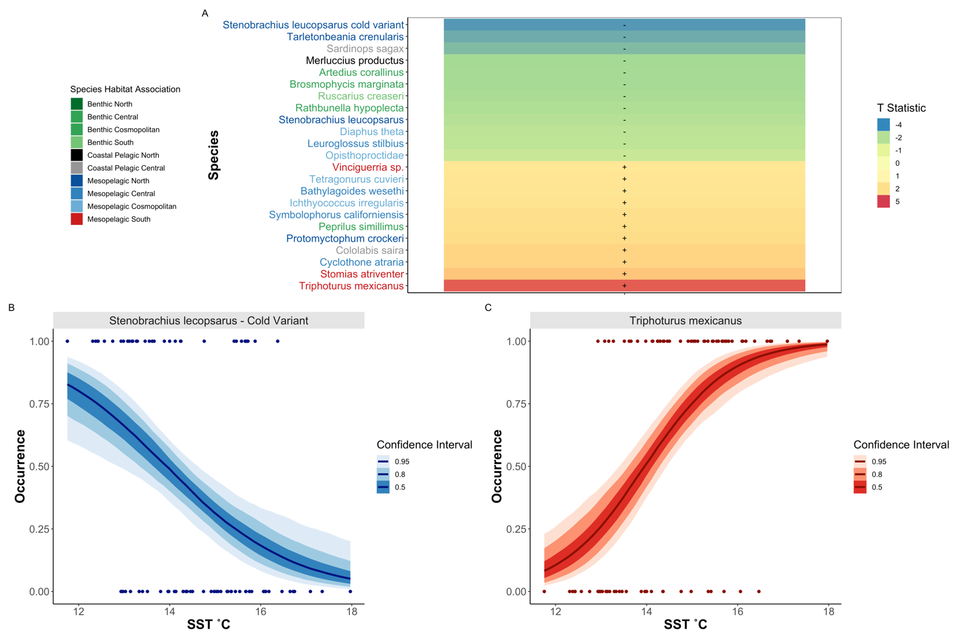

**Figure 1. Temperature Associations in Fish Species**

Changes in species *occurrence* patterns associated with SST, with southern mesopelagic species increasing in prevalence with elevated temperature (A). T statistic (slope coefficient/ standard error) from generalized binomial mixed model was calculated for each species across all sites. Only 23 out of 56 total species with significant slopes (95% CI that exclude zero) are plotted. Importantly, metabarcoding identified cold-associated variants of the Northern Lanternfish (*Stennobrachius leucopsarus*) that cannot be morphologically identified (B) as well as common warm-associated species such as the Mexican Lampfish (*Triphoturus mexicanus*) (C).

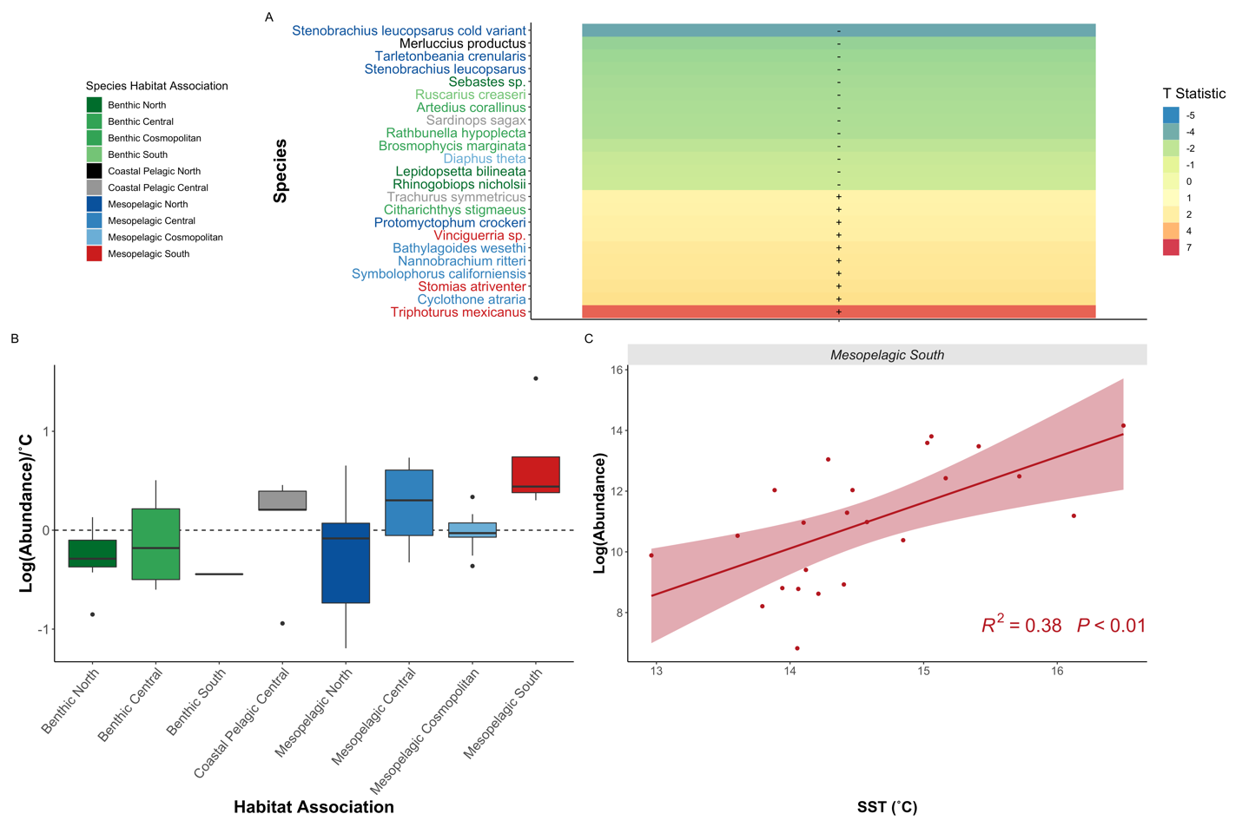**Figure 2. Southern Oceanic Species Drive Fish Community Shifts**

Changes in species *biomass* in response to temperature, with Southern Mesopelagic species increasing in abundance with elevated temperature (A). As in Fig 1, significant T statistics from generalized linear models are plotted. Southern mesopelagic fishes were associated with increased temperature as indicated by summarizing species-specific slopes from generalized linear models (B) and by the aggregated abundance relationship (C; each point is the mean posterior estimate of abundance for an individual southern mesopelagic species in a single year). In contrast, abundances of benthic species and coastal pelagic species such as Northern Hake and Pacific Sardine abundances, were associated with cooler temperatures.

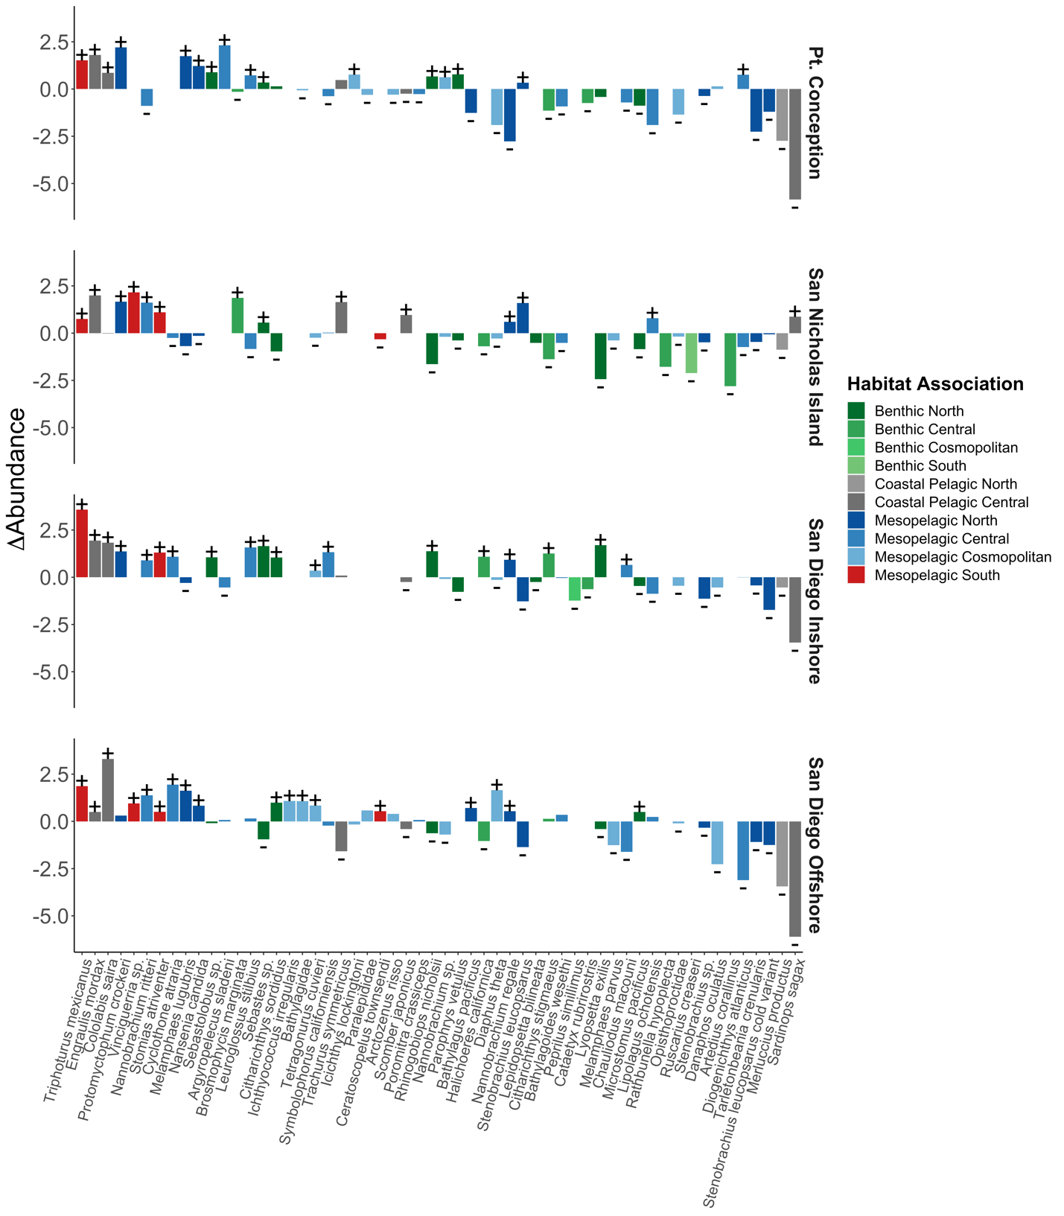

**Figure 3. Novel Marine Heatwave Assemblages**

Shifts in species abundances before the MHW (1996-2013) compared to during and after the MHW (2014-2019). Synchronous increases in southern mesopelagics and Northern Anchovy were observed across all sites. Here, sites are shown in rows, species in columns, and the change in abundance between the two ecological phases shown as the response variable. Fisheries targets including Pacific Sardine and North Pacific Hake, as well as many other benthic and coastal species, had concurrent negative associations. Significant differences during and after the MHW are marked with + or -.

Recent studies demonstrate the tropicalization of terrestrial and marine ecosystems in response to climate change (*40*, *41*). These shifts can induce novel species interactions, catalyzing changes in ecosystem function (*2*, *25*). For example, we observe the combination of high abundances of both anchovy and southern mesopelagics (*5*, *38*) – a pattern otherwise undocumented in the previous >70-year CalCOFI dataset (*16*, *20*). Although the ecological implications of these novel assemblages are, by definition, unpredictable, our results suggest that if future assemblages resemble those seen in the MHW, increases in Northern Anchovy and southern mesopelagic fishes are likely to be associated with decreases in Pacific Sardine and North Pacific Hake in the Southern CCLME (*42*, *43*); these shifts have fundamentally changed ecosystems and fisheries relative to the recent past (*20*).

***Biomass Changes in Forage Fishes***

Both because of their own commercial value and because they are prey for other high-value fishery species, sardine and anchovy fluctuations have been a major focus of fisheries research since the 1950s (*9*). Our model estimates are consistent with other studies (*20*, *44*) that documented a decline in both sardines and anchovy beginning in 2005 followed by high abundances of anchovy, but continued low abundances of sardine, in the wake of the MHW, 2015-2019 (Figure 4). Although anchovy larvae abundance was low in spring during the 2014-2016 MHW, anchovy recruitment was high in summer 2015 (*45*). Anchovy mature in approximately one to two years (*44*, *46*) and thus the 2015 class likely began spawning in mid-2016 (*20*), leading to high anchovy spawning stock biomass and larval abundances by 2016 and lasting into 2019 and 2020 (*58*).

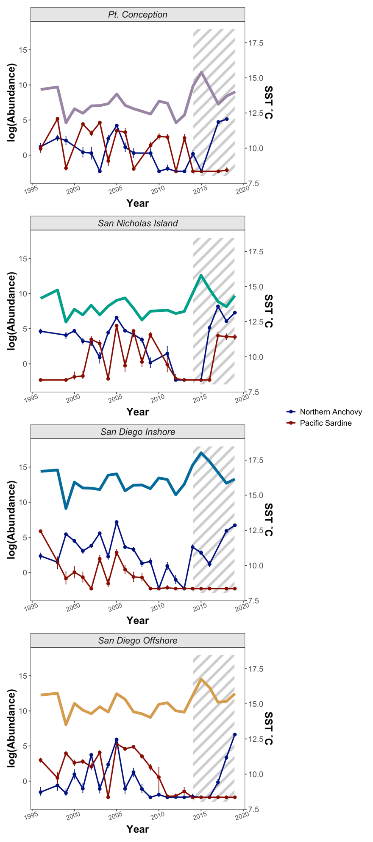

**Figure 4. Synchronous Increase in Anchovy Abundance During and After Marine Heatwave**

Posterior estimates for larval fish abundances (counts/10m2) over time at each of the four sampled sites, reconstructing increases in Northern Anchovy (*Engraulis mordax*) [blue] during the recent Pacific Marine Heatwave and low spawning of Pacific Sardine (*Sardinops* sagax) [red] over the past decade (points are means and error bars are 95% credible intervals; shaded region is during and after the MHW). SST is plotted above the Northern Anchovy and Pacific Sardine abundances, for reference.

The rise in anchovy and continued low abundances of sardine during the MHW is an ecological surprise. Correlative analyses between basin-scale environmental indices such as the Pacific Decadal Oscillation indicate that, for the latter half of the 20th century, anchovy thrived under cooler conditions and sardine under warmer conditions (*10*). However, our findings and others (*5*, *9*, *38*, *47*) suggest that the mechanisms that govern the population dynamics of these species are not a mere function of temperature, but that more complex factors drive recruitment dynamics of these species (*20*). For example, despite largely synchronous responses of fish assemblages to the marine heatwave, sardine declines were not consistent across the CCLME, with refugia of localized abundance in nearshore waters potentially driven by distinct, favorable environmental and biotic conditions(*9*, *20*, *55*).

Further improving our mechanistic understanding of drivers of fish assemblage dynamics will better inform ecological predictions in the face of climate change (*48*). As we demonstrate, a combination of metabarcoding and visual surveys can characterize species across trophic levels (*49*) and this has the potential to reveal ecological mechanisms. Here, we used metabarcoding to accurately characterize accurately the composition of larval fishes in CalCOFI plankton samples. Future efforts could focus on documenting the phytoplankton and zooplankton assemblages that comprise both larval prey and predators. Several major hypotheses seeking to explain recruitment variability are underpinned by the capacity of young larvae to consume appropriate prey that facilitates faster growth (*62*). Unfortunately, accurately characterizing the larval prey field has traditionally been very difficult as prey are generally too small to be accurately sampled by nets (*63*). Metabarcoding of water samples from the same locations where larvae are collected, however, can characterize the larval prey field at an unprecedentedly high level of detail. In addition, metabarcoding of the stomachs of larval fishes can then identify actual prey items that were consumed by larvae. Evaluating the larval prey field and gut contents through metabarcoding will can help us to finally understand the drivers of recruitment volatility in coastal pelagic and other fishes (*5*, *44*, *50*–*54*),.

The unexpected rise in anchovy during the 2014-16 MHW resonated throughout the CCLME (*39*). For example, California sea lion pups grew at anomalously high rates after their mothers consumed copious anchovy forage and produced ample milk (*42*). High rates of almost exclusively anchovy consumption also seemingly induced thiamine deficiency in adult salmon resulting in poor condition of recruits (*55*). Birds capable of feeding on anchovy thrived (*38*) while those unable to consume anchovy perished (*43*). Given that conditions comparable to the 2014–2016 MHW are predicted to be more common in the CCLME in the future (*1*), our results suggest that continued biological responses to both anchovy-dominated forage-fish assemblages and MHW-associated ocean warming conditions are likely to be without modern analogue (*20*).

***Novel Insights from Legacy Collections***

Molecular tools differentiated variants and species that were not morphologically identifiable in the ichthyoplankton (*21*).For example, metabarcoding identified unique cold-associated variants of the Northern Lampfish (*Stennobrachius leucopsarus*) that are morphologically indistinguishable and combined as a complex are only weakly associated with cooler temperatures. By illuminating such unseen variation, molecular methods reveal ecological dynamics otherwise hidden by shared larval morphology.

Ultimately, our approach to studying historical fluctuations in ichthyoplankton assemblages reveals climate-associated biological changes in the CCLME, and suggests ways in which these changes could alter the function and socio-economic benefits derived from marine ecosystems. Importantly, this novel approach provides quantitative estimates by non-destructively sampling legacy collections via metabarcoding, and at the same time provides a mechanistic framework for determining absolute abundance estimates from compositional amplicon sequencing data (*37*, *42*, *70*). Unlocking such quantitative metabarcoding approaches expands the potential for linking ecological assemblages to environmental processes beyond just presence absence analyses (*71*–*73*). Such quantitative approaches may prove critical in modeling and predicting future ecosystem change, although directly linking assemblage dynamic responses to climate-driven forces remains inherently challenging. While the CalCOFI samples are specific to ichthyoplankton from the CCLME, bulk collection of community samples is commonly used to survey plankton, insects, pollen, gut contents, and microbiomes, among many other targets (*74*). As such, here we provide broadly applicable methodology with which to efficiently understand modern and historical changes in ecological communities.

1. E. C. J. Oliver, S. E. Perkins-Kirkpatrick, N. J. Holbrook, N. L. Bindoff, 9. Anthropogenic and natural influences on record 2016 marine heat waves. *Bull. Am. Meteorol. Soc.* **99**, S44–S48 (2018).

2. T. L. Frölicher, C. Laufkötter, Emerging risks from marine heat waves. *Nat. Commun.* **9** (2018), pp. 1–4.

3. T. P. Hughes, J. T. Kerry, A. H. Baird, S. R. Connolly, A. Dietzel, C. M. Eakin, S. F. Heron, A. S. Hoey, M. O. Hoogenboom, G. Liu, M. J. McWilliam, R. J. Pears, M. S. Pratchett, W. J. Skirving, J. S. Stella, G. Torda, Global warming transforms coral reef assemblages. *Nature*. **556**, 492–496 (2018).

4. L. Rogers-Bennett, C. A. Catton, Marine heat wave and multiple stressors tip bull kelp forest to sea urchin barrens. *Sci. Rep.* **9**, 1–9 (2019).

5. J. M. Nielsen, L. A. Rogers, R. D. Brodeur, A. R. Thompson, T. D. Auth, A. L. Deary, J. T. Duffy-Anderson, M. Galbraith, J. A. Koslow, R. I. Perry, Responses of ichthyoplankton assemblages to the recent marine heatwave and previous climate fluctuations in several Northeast Pacific marine ecosystems. *Glob. Chang. Biol.* **27**, 506–520 (2021).

6. W. W. L. Cheung, T. L. Frölicher, Marine heatwaves exacerbate climate change impacts for fisheries in the northeast Pacific. *Sci. Rep.* **10**, 1–10 (2020).

7. M. L. Pinsky, R. L. Selden, Z. J. Kitchel, Climate-Driven Shifts in Marine Species Ranges: Scaling from Organisms to Communities. *Ann. Rev. Mar. Sci.* **12**, 153–179 (2020).

8. E. A. Becker, K. A. Forney, J. V. Redfern, J. Barlow, M. G. Jacox, J. J. Roberts, D. M. Palacios, Predicting cetacean abundance and distribution in a changing climate. *Divers. Distrib.* **25**, 626–643 (2019).

9. D. M. Checkley, R. G. Asch, R. R. Rykaczewski, Climate, Anchovy, and Sardine. *Ann. Rev. Mar. Sci.* **9**, 469–493 (2017).

10. F. P. Chavez, J. Ryan, S. E. Lluch-Cota, C. M. Ñiquen, Climate: From anchovies to sardines and back: Multidecadal change in the Pacific Ocean. *Science (80-. ).* **299**, 217–221 (2003).

11. M. Lindegren, D. M. Checkley, T. Rouyer, A. D. MacCall, N. C. Stenseth, Climate, fishing, and fluctuations of sardine and anchovy in the California Current. *Proc. Natl. Acad. Sci. U. S. A.* **110**, 13672–13677 (2013).

12. N. D. Gallo, E. Drenkard, A. R. Thompson, E. D. Weber, D. Wilson-Vandenberg, S. McClatchie, J. A. Koslow, B. X. Semmens, Bridging From Monitoring to Solutions-Based Thinking: Lessons From CalCOFI for Understanding and Adapting to Marine Climate Change Impacts. *Front. Mar. Sci.* **6**, 695 (2019).

13. P. E. Smith, H. G. Moser, Long-term trends and variability in the larvae of Pacific sardine and associated fish species of the California Current region. *Deep. Res. Part II Top. Stud. Oceanogr.* **50**, 2519–2536 (2003).

14. C. H. Hsieh, C. S. Reiss, J. R. Hunter, J. R. Beddington, R. M. May, G. Sugihara, Fishing elevates variability in the abundance of exploited species. *Nature*. **443**, 859–862 (2006).

15. A. R. Thompson, W. Watson, S. McClatchie, E. D. Weber, Multi-scale sampling to evaluate assemblage dynamics in an oceanic marine reserve. *PLoS One*. **7**, e33131 (2012).

16. H. G. Moser P.E. Smith, and L.E. Eber, Larval fish assemblages in the California Current region, 1954-1960, a period of dynamic environmental change. *CalCOFI Rep.* **28**, 97–127 (1987).

17. H. Moser, R. Charter, P. Smith, D. Ambrose, W. Watson, S. Charter, E. Sandknop, Distributional atlas of fish larvae and eggs in the Southern California Bight region: 1951-1998. *Calif. Coop. Ocean. Fish. Investig. Atlas*. **34**, 1–166 (2001).

18. M. A. Snyder, L. C. Sloan, N. S. Diffenbaugh, J. L. Bell, Future climate change and upwelling in the California Current. *Geophys. Res. Lett.* **30**, 1823 (2003).

19. R. G. Asch, Climate change and decadal shifts in the phenology of larval fishes in the California Current ecosystem. *Proc. Natl. Acad. Sci. U. S. A.* **112**, E4065–E4074 (2015).

20. A. R. Thompson, N. J. Ben-Aderet, N. M. Bowlin, D. Kacev, R. Swalethorp, W. Watson, Putting the Pacific marine heatwave into perspective: The response of larval fish off southern California to unprecedented warming in 2014–2016 relative to the previous 65 years. *Glob. Chang. Biol.* **28**, 1766–1785 (2022).

21. A. R. Thompson, D. C. Chen, L. W. Guo, J. R. Hyde, W. Watson, Larval abundances of rockfishes that were historically targeted by fishing increased over 16 years in association with a large marine protected area. *R. Soc. Open Sci.* **4**, 170639 (2017).

22. Z. Gold, E. E. Curd, K. D. Goodwin, E. S. Choi, B. W. Frable, A. R. Thompson, H. J. Walker, R. S. Burton, D. Kacev, L. D. Martz, P. H. Barber, Improving metabarcoding taxonomic assignment: A case study of fishes in a large marine ecosystem. *Mol. Ecol. Resour.* **21**, 2546–2564 (2021).

23. M. Miya, R. O. Gotoh, T. Sado, MiFish metabarcoding: a high-throughput approach for simultaneous detection of multiple fish species from environmental DNA and other samples. *Fish. Sci.* **86**, 939–970 (2020).

24. M. G. Jacox, M. A. Alexander, N. J. Mantua, J. D. Scott, G. Hervieux, R. S. Webb, F. E. Werner, 6. Forcing of multiyear extreme ocean temperatures that impacted California current living marine resources in 2016. *Bull. Am. Meteorol. Soc.* **99**, S27–S33 (2018).

25. C. A. Morgan, B. R. Beckman, L. A. Weitkamp, K. L. Fresh, Recent Ecosystem Disturbance in the Northern California Current. *Fisheries*. **44**, 465–474 (2019).

26. C. L. Gentemann, M. R. Fewings, M. García-Reyes, Satellite sea surface temperatures along the West Coast of the United States during the 2014–2016 northeast Pacific marine heat wave. *Geophys. Res. Lett.* **44**, 312–319 (2017).

27. A. S. Ren, D. L. Rudnick, Temperature and salinity extremes from 2014-2019 in the California Current System and its source waters. *Commun. Earth Environ.* **2**, 1–9 (2021).

28. I. D. Schroeder, J. A. Santora, S. J. Bograd, E. L. Hazen, K. M. Sakuma, A. M. Moore, C. A. Edwards, B. K. Wells, J. C. Field, Source water variability as a driver of rockfish recruitment in the California Current Ecosystem: implications for climate change and fisheries management. *Can. J. Fish. Aquat. Sci.* **76**, 950–960 (2019).

29. S. McClatchie, A. R. Thompson, S. R. Alin, S. Siedlecki, W. Watson, S. J. Bograd, The influence of Pacific Equatorial Water on fish diversity in the southern California Current System. *J. Geophys. Res. Ocean.* **121**, 6121–6136 (2016).

30. A. R. Thompson, C. J. Harvey, W. J. Sydeman, C. Barceló, S. J. Bograd, R. D. Brodeur, J. Fiechter, J. C. Field, N. Garfield, T. P. Good, E. L. Hazen, M. E. Hunsicker, K. Jacobson, M. G. Jacox, A. Leising, J. Lindsay, S. R. Melin, J. A. Santora, I. D. Schroeder, J. A. Thayer, B. K. Wells, G. D. Williams, Indicators of pelagic forage community shifts in the California Current Large Marine Ecosystem, 1998–2016. *Ecol. Indic.* **105**, 215–228 (2019).

31. H. G. Moser, R. L. Charter, P. E. Smith, D. A. Ambrose, S. R. Charter, C. A. Meyer, E. M. Sandknop, W. Watson, *Distributional atlas of fish larvae and eggs in the California Current region: taxa with 1000 or more total larvae, 1951 through 1984* (Marine Life Research Program, Scripps Institution of Oceanography, 1993), vol. 53.

32. C. H. Hsieh, C. Reiss, W. Watson, M. J. Allen, J. R. Hunter, R. N. Lea, R. H. Rosenblatt, P. E. Smith, G. Sugihara, A comparison of long-term trends and variability in populations of larvae of exploited and unexploited fishes in the Southern California region: A community approach. *Prog. Oceanogr.* **67**, 160–185 (2005).

33. A. R. Thompson, S. McClatchie, E. D. Weber, W. Watson, C. E. Lennert-Cody, Correcting for bias in calcofi ichthyoplankton abundance estimates associated with the 1977 transition from ring to bongo net sampling. *Calif. Coop. Ocean. Fish. Investig. Reports*. **58**, 1–11 (2017).

34. D. Kramer, M. J. Kalin, E. G. Stevens, J. R. Thrailkill, J. . Zweifel, *Collecting and processing data on fish eggs and larvae in the California Current. NOAA Tech. Rep. NMFS Circ., vol. 370.* (US Department of Commerce, National Oceanic and Atmospheric Administration …, 1972), vol. 370.

35. S. McClatchie, *Regional fisheries oceanography of the california current system: The CalCOFI program* (Springer, 2014).

36. M. Miya, Y. Sato, T. Fukunaga, T. Sado, J. Y. Poulsen, K. Sato, T. Minamoto, S. Yamamoto, H. Yamanaka, H. Araki, M. Kondoh, W. Iwasaki, MiFish, a set of universal PCR primers for metabarcoding environmental DNA from fishes: Detection of more than 230 subtropical marine species. *R. Soc. Open Sci.* **2**, 150088 (2015).

37. M. R. McLaren, A. D. Willis, B. J. Callahan, Consistent and correctable bias in metagenomic sequencing experiments. *Elife*. **8**, e46923 (2019).

38. J. D. Silverman, R. J. Bloom, S. Jiang, H. K. Durand, E. Dallow, S. Mukherjee, L. A. David, Measuring and mitigating PCR bias in microbiota datasets. *PLoS Comput. Biol.* **17**, e1009113 (2021).

39. R. P. Kelly, A. O. Shelton, R. Gallego, Understanding PCR Processes to Draw Meaningful Conclusions from Environmental DNA Studies. *Sci. Rep.* **9**, 1–14 (2019).

40. J. D. Silverman, K. Roche, S. Mukherjee, L. A. David, Naught all zeros in sequence count data are the same. *Comput. Struct. Biotechnol. J.* **18**, 2789–2798 (2020).

41. J. J. Jos´, J. Egozcue, J. Graffelman, M. I. Ortego, V. Pawlowsky-Glahn, Some thoughts on counts in sequencing studies. *NAR Genomics Bioinforma.* **2**, 1–10 (2020).

42. G. B. Gloor, J. M. Macklaim, V. Pawlowsky-Glahn, J. J. Egozcue, Microbiome datasets are compositional: And this is not optional. *Front. Microbiol.* **8**, 2224 (2017).

43. X. Ren, P. F. Kuan, Negative binomial additive model for RNA-Seq data analysis. *BMC Bioinformatics*. **21**, 1–15 (2020).

44. T. Chambert, D. S. Pilliod, C. S. Goldberg, H. Doi, T. Takahara, An analytical framework for estimating aquatic species density from environmental DNA. *Ecol. Evol.* **8**, 3468–3477 (2018).

45. E. Meyer-Gutbrod, L. Kui, R. Miller, M. Nishimoto, L. Snook, M. Love, Moving on up: Vertical distribution shifts in rocky reef fish species during climate-driven decline in dissolved oxygen from 1995 to 2009. *Glob. Chang. Biol.* **27**, 6280–6293 (2021).

46. B. Goodrich, J. Gabry, I. Ali, S. Brilleman, rstanarm: Bayesian applied regression modeling via Stan. *R Packag. version*. **2**, 1758 (2020).

47. M. Miya, Y. Sato, T. Fukunaga, T. Sado, J. Y. Poulsen, K. Sato, T. Minamoto, S. Yamamoto, H. Yamanaka, H. Araki, M. Kondoh, W. Iwasaki, MiFish, a set of universal PCR primers for metabarcoding environmental DNA from fishes: Detection of more than 230 subtropical marine species. *R. Soc. Open Sci.* **2**, 150088 (2015).

48. E. E. Curd, Z. Gold, G. S. Kandlikar, J. Gomer, M. Ogden, T. O’Connell, L. Pipes, T. M. Schweizer, L. Rabichow, M. Lin, B. Shi, P. H. Barber, N. Kraft, R. Wayne, R. S. Meyer, Anacapa Toolkit: An environmental DNA toolkit for processing multilocus metabarcode datasets. *Methods Ecol. Evol.* **10**, 1469–1475 (2019).

49. R. Gallego, E. Jacobs-Palmer, K. Cribari, R. P. Kelly, Environmental DNA metabarcoding reveals winners and losers of global change in coastal waters: EDNA and climate change. *Proc. R. Soc. B Biol. Sci.* **287**, 20202424 (2020).

50. J. A. Santora, N. J. Mantua, I. D. Schroeder, J. C. Field, E. L. Hazen, S. J. Bograd, W. J. Sydeman, B. K. Wells, J. Calambokidis, L. Saez, D. Lawson, K. A. Forney, Habitat compression and ecosystem shifts as potential links between marine heatwave and record whale entanglements. *Nat. Commun.* **11**, 1–12 (2020).

51. A. Vergés, C. Doropoulos, H. A. Malcolm, M. Skye, M. Garcia-Pizá, E. M. Marzinelli, A. H. Campbell, E. Ballesteros, A. S. Hoey, A. Vila-Concejo, Y. M. Bozec, P. D. Steinberg, Long-term empirical evidence of ocean warming leading to tropicalization of fish communities, increased herbivory, and loss of kelp. *Proc. Natl. Acad. Sci. U. S. A.* **113**, 13791–13796 (2016).

52. C. Chaudhary, A. J. Richardson, D. S. Schoeman, M. J. Costello, Global warming is causing a more pronounced dip in marine species richness around the equator. *Proc. Natl. Acad. Sci. U. S. A.* **118** (2021), doi:10.1073/pnas.2015094118.

53. H. Robinson, J. Thayer, W. J. Sydeman, M. Weise, Changes in California sea lion diet during a period of substantial climate variability. *Mar. Biol.* **165**, 1–12 (2018).

54. J. F. Piatt, J. K. Parrish, H. M. Renner, S. K. Schoen, T. T. Jones, M. L. Arimitsu, K. J. Kuletz, B. Bodenstein, M. García-Reyes, R. S. Duerr, R. M. Corcoran, R. S. A. Kaler, G. J. McChesney, R. T. Golightly, H. A. Coletti, R. M. Suryan, H. K. Burgess, J. Lindsey, K. Lindquist, P. M. Warzybok, J. Jahncke, J. Roletto, W. J. Sydeman, Extreme mortality and reproductive failure of common murres resulting from the northeast Pacific marine heatwave of 2014-2016. *PLoS One*. **15**, e0226087 (2020).

55. W. J. Sydeman, S. Dedman, M. García-Reyes, S. A. Thompson, J. A. Thayer, A. Bakun, A. D. MacCall, Sixty-five years of northern anchovy population studies in the southern California Current: A review and suggestion for sensible management. *ICES J. Mar. Sci.* **77**, 486–499 (2020).

56. A. R. Thompson, I. D. Schroeder, S. J. Bograd, E. L. Hazen, M. G. Jacox, A. Leising, B. K. Wells, J. L. Largier, J. L. Fisher, K. C. Jacobson, S. M. Zeman, E. P. Bjorktedt, R. R. Robertson, M. Kahru, R. Goericke, C. E. Peabody, T. Baumgartner, B. E. Lavaniegos, L. E. Miranda, E. Gómez-Ocampo, J. Gómez-Valdés, T. D. Authy, E. A. Daly, C. A. Morgan, J. B. Burke, J. C. Field, K. Sakuma, E. D. Weber, W. Watson, J. M. Porquez, J. Dolliver, D. E. Lyons, R. A. Orben, J. Zamon, P. Warybok, J. Jahncke, J. A. Santora, S. A. Thompson, B. Hoover, W. J. Sydeman, S. Melin, State of the California current 2018-19 : a novel anchovy regime and a new marine heat wave? *Calif. Coop. Ocean. Fish. Investig. Rep.* **60**, 1–60 (2019).

57. R. H. Parrish, D. L. Mallicoate, R. A. Klingbeil, Age dependent fecundity, number of spawninge per year, sex ratio, and maturation stages in northern anchovy, Engraulis mordax. *Fish. Bull.* **84**, 503–517 (1986).

58. E. D. Weber, T. D. Auth, S. Baumann-Pickering, T. R. Baumgartner, E. P. Bjorkstedt, S. J. Bograd, B. J. Burke, J. L. Cadena-Ramírez, E. A. Daly, M. de la Cruz, State of the California Current 2019–2020: Back to the Future With Marine Heatwaves? *Front. Mar. Sci.*, 1081 (2021).

59. S. McClatchie, Sardine biomass is poorly correlated with the Pacific Decadal Oscillation off California. *Geophys. Res. Lett.* **39** (2012), doi:10.1029/2012GL052140.

60. C. Deutsch, A. Ferrel, B. Seibel, H. O. Pörtner, R. B. Huey, Climate change tightens a metabolic constraint on marine habitats. *Science (80-. ).* **348**, 1132–1135 (2015).

61. K. A. Rose, J. Fiechter, E. N. Curchitser, K. Hedstrom, M. Bernal, S. Creekmore, A. Haynie, S. ichi Ito, S. Lluch-Cota, B. A. Megrey, C. A. Edwards, D. Checkley, T. Koslow, S. McClatchie, F. Werner, A. MacCall, V. Agostini, Demonstration of a fully-coupled end-to-end model for small pelagic fish using sardine and anchovy in the California Current. *Prog. Oceanogr.* **138**, 348–380 (2015).

62. J. A. Hare, The future of fisheries oceanography lies in the pursuit of multiple hypotheses. *ICES J. Mar. Sci.* **71**, 2343–2356 (2014).

63. D. Robert, H. M. Murphy, G. P. Jenkins, L. Fortier, Poor taxonomical knowledge of larval fish prey preference is impeding our ability to assess the existence of a “critical period” driving year-class strength. *ICES J. Mar. Sci.* **71**, 2042–2052 (2014).

64. E. Garcia-Vazquez, O. Georges, S. Fernandez, A. Ardura, eDNA metabarcoding of small plankton samples to detect fish larvae and their preys from Atlantic and Pacific waters. *Sci. Rep.* **11**, 1–13 (2021).

65. K. J. Pitz, J. Guo, S. B. Johnson, T. L. Campbell, H. Zhang, R. C. Vrijenhoek, F. P. Chavez, J. Geller, Zooplankton biogeographic boundaries in the California Current System as determined from metabarcoding. *PLoS One*. **15**, e0235159 (2020).

66. C. Mariac, J. F. Renno, G. Carmen, Y. Vigouroux, E. Mejia, C. Angulo, D. Castro Ruiz, G. Estivals, C. Nolorbe, A. García Vasquez, J. Nuñez, G. Cochonneau, M. Flores, J. Alvarado, J. Vertiz, W. Chota-Macuyama, H. Sánchez, G. Miranda, F. Duponchelle, Species-level ichthyoplankton dynamics for 97 fishes in two major river basins of the Amazon using quantitative metabarcoding. *Mol. Ecol.* (2021), doi:10.1111/mec.15944.

67. M. Barbato, T. Kovacs, M. A. Coleman, M. K. Broadhurst, M. de Bruyn, Metabarcoding for stomach-content analyses of Pygmy devil ray (Mobula kuhlii cf. eregoodootenkee): Comparing tissue and ethanol preservative-derived DNA. *Ecol. Evol.* **9**, 2678–2687 (2019).

68. M. Erdozain, D. G. Thompson, T. M. Porter, K. A. Kidd, D. P. Kreutzweiser, P. K. Sibley, T. Swystun, D. Chartrand, M. Hajibabaei, Metabarcoding of storage ethanol vs. conventional morphometric identification in relation to the use of stream macroinvertebrates as ecological indicators in forest management. *Ecol. Indic.* **101**, 173–184 (2019).

69. H. L. Thalmann, E. A. Daly, R. D. Brodeur, Two Anomalously Warm Years in the Northern California Current: Impacts on Early Marine Steelhead Diet Composition, Morphology, and Potential Survival. *Trans. Am. Fish. Soc.* **149**, 369–382 (2020).

70. R. P. Kelly, J. A. Port, K. M. Yamahara, R. G. Martone, N. Lowell, P. F. Thomsen, M. E. Mach, M. Bennett, E. Prahler, M. R. Caldwell, L. B. Crowder, Harnessing DNA to improve environmental management. *Science (80-. ).* **344**, 1455–1456 (2014).

71. M. Y. Stoeckle, J. Adolf, Z. Charlop-Powers, K. J. Dunton, G. Hinks, S. M. Vanmorter, Trawl and eDNA assessment of marine fish diversity, seasonality, and relative abundance in coastal New Jersey, USA. *ICES J. Mar. Sci.* **78**, 293–304 (2021).

72. A. Lacoursière-Roussel, G. Côté, V. Leclerc, L. Bernatchez, Quantifying relative fish abundance with eDNA: a promising tool for fisheries management. *J. Appl. Ecol.* **53**, 1148–1157 (2016).

73. M. C. Yates, D. J. Fraser, A. M. Derry, Meta-analysis supports further refinement of eDNA for monitoring aquatic species-specific abundance in nature. *Environ. DNA*. **1**, 5–13 (2019).

74. M. M. Zenker, A. Specht, V. G. Fonseca, Assessing insect biodiversity with automatic light traps in Brazil: Pearls and pitfalls of metabarcoding samples in preservative ethanol. *Ecol. Evol.* **10**, 2352–2366 (2020).

75. R. P. Kelly, R. Gallego, E. Jacobs-Palme, The effect of tides on nearshore environmental DNA. *PeerJ*. **2018**, e4521 (2018).

76. R. Mendelssohn, rerddapXtracto: Extracts Environmental Data from “ERDDAP” Web Services. R package version 1.0.0 (2020).

77. H. G. Moser, R. L. Charter, W. Watson, D. A. Ambrose, K. T. Hill, P. E. Smith, J. L. Butler, E. M. Sandknop, S. R. Charter, The CalCOFI ichthyoplankton time series: Potential contributions to the management of rocky-shore fishes. *Calif. Coop. Ocean. Fish. Investig. Reports*. **42**, 112–128 (2001).

78. S. Juggins, rioja: Analysis of Quaternary science data, R package version (0.9-9). *Compr. r Arch. Netw.* (2015).

79. A. de Vries, B. D. Ripley, Create Dendrograms and Tree Diagrams Using “ggplot2.” *URL https//github. com/andrie/ggdendro*, 12 (2020).

80. J. Oksanen, F. G. Blanchet, R. Kindt, P. Legendre, P. R. Minchin, O. R.B., G. L. Simpson, P. Solymos, M. H. H. Stevens, H. Wagner, *vegan*: Community ecology package. *R Packag. version 2.3-5* (2016), (available at https://cran.r-project.org/package=vegan).

81. J. Niku, F. K. C. Hui, S. Taskinen, D. I. Warton, gllvm: Fast analysis of multivariate abundance data with generalized linear latent variable models in r. *Methods Ecol. Evol.* **10**, 2173–2182 (2019).

**SUPPLEMENT 1**

**Table of Contents**

1. **Methods**
   1. *Study Design*
   2. *Metabarcoding Collection Isolation, Amplification, and Sequencing*
   3. *Bioinformatics*
   4. *Microscopy Identification of Ichthyoplankton*
   5. *Estimating Abundance (see Supplement 2)*
   6. *Environmental Covariates*
   7. *Data analysis*
2. **Results**
   1. *Change in Fish Assemblage Structure over Time*
   2. *Metabarcoding Signal Does Not Degrade Over Time*
3. **Figures**
   1. *Figure S1. Predicted Counts vs. Observed Morphological Counts*
   2. *Figure S2. Predicted Sequence Reads vs. Observed Sequence Reads*
   3. *Figure S3. Observed Sequence Reads vs. Observed Morphological Counts*
   4. *Figure S4. Co-detection of Taxa By Metabarcoding and Microscopy*
   5. *Figure S5. Site Map*
   6. *Figure S6. Temperature Associations in Fish Species*
   7. *Figure S7. Southern Oceanic Species Drive Fish Community Shifts*
   8. *Figure S8. Significant Species Occurrence and SST Correlations at each Site*
   9. *Figure S9. Significant Species Occurrence and MWCT Correlations at each Site*
   10. *Figure S10. Significant Species Abundance and SST Correlations at each Site*
   11. *Figure S11. Significant Species Abundance and MWCT Correlations at each Site*
   12. *Figure S12. Bar Plot of Significant Species Abundance and SST Correlations Across All Sites*
   13. *Figure S13. Bar Plot of Significant Species Abundance and MWCT Correlations Across All Sites*
   14. *Figure S14. Increased Abundance of Southern Mesopelagic Species with Higher SST*
   15. *Figure S15. Increased Abundance of Southern and Central Mesopelagic Species with Higher SST*
   16. *Figure S16. Heat Map of Abundances Over Time*
   17. *Figure S17. NMDS Ordination of Species and Years*
   18. *Figure S18. NMDS Ordination of Species and Samples*
   19. *Figure S19. Heat Map of San Diego Offshore Abundances Over Time*
   20. *Figure S20. NMDS Ordination of San Diego Offshore Species and Years*
   21. *Figure S21. Heat Map of San Diego Inshore Abundances Over Time*
   22. *Figure S22. NMDS Ordination of San Diego Inshore Species and Years*
   23. *Figure S23. Heat Map of Pt. Conception Abundances Over Time*
   24. *Figure S24. NMDS Ordination of Pt. Conception Species and Years*
   25. *Figure S25. Heat Map of San Nicholas Island Abundances Over Time*
   26. *Figure S26. NMDS Ordination of San Nicholas Island Species and Years*
   27. *Figure S27. Co-occurrence Patterns of Species Controlling for SST*
   28. *Figure S28. Co-occurrence Patterns of Species*
   29. *Figure S39. Differential Species Abundance Before and After the Marine Heat Wave at the San Nicholas Island*
   30. *Figure S30. Stable Precision of Amplicon Abundance Over Time*
   31. *Figure S31. Stable Precision of Abundance Estimates Over Time*

**Methods**

*Study Design*

To evaluate the efficacy of eDNA methods and investigate decadal changes in the ichthyoplankton assemblages in the California Current vicinity, we identified ichthyoplankton from four distinct stations with variable water properties (*64*) collected in spring over 2 decades (1996,1998-2019; Figure S5) (*5*, *38*). The northernmost station was located in the California Current (34.14833˚N -121.1567˚W) offshore of Point Conception, CA. A second station was chosen off of San Nicholas Island, CA (33.32333 ˚N, -119.6667˚W) that experiences high variation in annual temperature depending on the respective strengths of the California Current and Southern California Counter Current (*64*). We also chose a Southern coastal inshore site off San Diego, CA (32.84667˚N, -117.5383˚W) which is typically characterized by warmer waters from the California Counter Current, but also experiences seasonal upwelling (*64*). Lastly, we chose a southern offshore site (31.85000˚N, -119.5683˚W) which is characterized by sub-tropical oceanic waters. Samples were collected during spring CalCOFI cruises of each year in late March or early April (calcofi_metadata_analysis_20210907.csv). We note that samples collected in 1997 were stored in <50% ethanol and were discarded due to failed preservation.

At each station, oblique bongo net tows were conducted from 210 m to the surface using standard CalCOFI methods (*15*, *34*, *65*, *66*). Each side of the bongo net had a 0.71 m-diameter mouth opening and a net size of 0.505 mm mesh. Cod end contents of both bongo nets were preserved at sea. The starboard side was preserved in sodium borate-buffered 2% formaldehyde and the port side was preserved in Tris-buffered 95% ethanol. Ethanol was replaced after 24 hours to account for dilution from tissue water loss. Microscopy was conducted to identify species abundance from formaldehyde-preserved samples following standardized CalCOFI techniques (*64*) while metabarcoding was conducted on the ethanol in which port side samples were stored; consequently, we expect the contents of the paired samples to differ slightly as a function of sampling stochasticity.

*Metabarcoding Collection Isolation, Amplification, and Sequencing*

Prior to filtration, samples were inverted three times and let rest for 30 minutes to resuspend and homogenize samples in the preservative. Filtration of ethanol from the port-side bongo samples was conducted in a pre-PCR clean room at the NOAA SWFSC within a biological safety cabinet in July 2019. The pre-PCR room had no previous post-PCR work conducted within and all surfaces and equipment were sterilized frequently with 10% bleach and 70% ethanol. The pre-PCR clean room was at ambient pressure and reasonable precautions to limit contamination were conducted including only wearing clean clothes that have not been exposed to labs with PCR product, no food brought into the lab, and gloves were exchanged regularly.

Ethanol preservative was filtered using a vacuum filtration manifold with Nalgene Analytical Test Filter Funnels (Thermofisher Scientific, Waltham, MA, USA) with the manufacturer’s 0.45 µm filters replaced with 0.2 µm Durapore PVDF filters (Sigma Aldrich, St. Louis, MO, USA) using sterile forceps. Up to 125 mL of ethanol was then transferred from the preserved jars into the filter funnels using a 10 mL pipette, carefully avoiding any sample contents and thus preserving CalCOFI specimens for future research and analysis. Sample jars were refilled using freshly prepared tris-buffered ethanol before being returned to the collection archive. We included two negative controls to test for lab contamination by filtering 125 mL of molecular grade water. Filters were stored at -20˚C before DNA extraction.

Filters were extracted using the standard Qiagen DNAeasy Kit (Qiagen Inc., Valencia, CA, USA) in a pre-PCR molecular lab. We amplified extracted DNA using both MiFish Universal Teleost primer set to capture fish diversity (*32*)*.* Each eDNA extraction was subsampled for three PCR reactions . PCR amplification for the MiFish primer set was conducted following the thermocycler profile of Curd *et al.* (*30*). MiFish PCR reactions had 25 μL reaction volume containing 12.5 μL QIAGEN Multiplex Taq PCR 2x Master Mix (Qiagen Inc., Valencia, CA, USA), 6.5 µL of molecular grade water, 2.5 µL of each primer (2 µmol/L), and 1 μL DNA extraction. MiFish PCR thermocycling employed a touchdown profile with an initial denaturation at 95°C for 15 min to activate the DNA polymerase, followed by 13 cycles of a 30s denaturation at 94°C, a 30s annealing that started at 69.5°C and then decreased by 1.5°C for each subsequent cycle (last cycle was 50°C), finishing with a 1 min extension at 72°C. This initial touchdown profile was followed by 35 additional cycles using identical parameters except a constant annealing temperature of 50°C and ending with a final extension at 72°C for 10 min. Two non-native non-marine vertebrates, American alligator (*Alligator mississippiensis*) and dromedary camel (*Camelus dromedarius*), were purchased at a local market and used as positive controls. For all positive controls, tissues were extracted using the Qiagen Blood and Tissue kit following the manufacturer’s instructions. All PCR products were visualized via electrophoresis on 2% agarose gels to ensure amplification success and correct product size. Only filters from 4 jars failed to amplify, and upon further inspection within the archived notes, all these samples had known preservation issues (e.g. preservative dried out, observed mold, etc.). All other DNA extractions successfully amplified.

We prepared libraries following the methods of Curd *et al.*  with one final pool per primer set. PCR samples were cleaned using the Serapure magnetic bead protocol . We quantified bead-cleaned samples with the Quant-iT™ broad range dsDNA Assay Kit (Thermofisher Scientific, Waltham, MA, USA) on a Victor3 plate reader (Perkin Elmer Waltham, MA, USA). We indexed the sample libraries using unique combinations of the Nextera Index A, B, C, and D Kit (Illumina, San Diego, CA, USA) and KAPA HiFi HotStart Ready Mix (Kapa Biosystems, Sigma Aldrich, St. Louis, MO, USA). Indexing was performed with a second PCR using a 25 μL reaction mixture containing 12.5 μL of Kapa HiFi Hotstart Ready mix, 1.25 μL of index primers, 10 ng of template DNA to ensure equal copy number, and the remaining volume was filled using molecular grade water depending on cleaned PCR product concentration. Index thermocycling parameters were: denaturation at 95˚C for 5 min, 5 cycles of denaturation at 98˚C for 20 sec, annealing at 56˚C for 30 sec, extension at 72˚C for 3 min, followed by a final extension at 72˚C for 5 min. To confirm successful PCR and correct product size, we electrophoresed PCR products on 2% agarose gels. We then bead cleaned and quantified DNA concentration, as described above so that we could pool samples so as to have equal copy number for each unique library. Pooled libraries were sequenced on an Illumina NextSeq PE 2x150 at UCLA Technology Center for Genomics and Bioinformatics.

*Bioinformatics*

The resulting metabarcoding data were processed using the *Anacapa Toolkit* to conduct quality control, amplicon sequence variant (ASV) parsing, and taxonomic assignment using user-generated custom reference databases . We processed sequences using default parameters except using a Q score cutoff of 30 and assigned taxonomy using *CRUX*-generated metabarcode specific reference databases (*22*). The MiFish sequencing data was assigned taxonomy using the California fish specific reference database and a bootstrap confidence cutoff score of 60 following Gold *et al.* (*22*).

The three resulting raw ASV community tables were decontaminated following Kelly et al. (*69*). First, only merged paired reads that occurred at least twice (e.g., no singletons) were retained. Second, we estimated index hopping between samples by calculating the proportion of sequences within the positive control samples and then subtracting reads from each sample by the sample read depth multiplied by the proportion of reads observed in the positive controls. Third, we discarded technical replicates with fewer than 30,000 reads. Fourth, we calculated Bray-Curtis dissimilarities between technical PCR replicates and fit a skewed beta distribution (a= 0.6, b= 9.5). We then removed all replicates with greater than 95% probability of belonging to the beta distribution. Resulting tables were then combined into a final ASV community table in *R.*

*Microscopy Identification of Ichthyoplankton*

Plankton samples were processed at the NOAA Southwest Fisheries Science Center ichthyoplankton laboratory. From each plankton sample, fish larvae were sorted and identified through microscopy to the lowest practical taxon (*34*, *66*). Most taxa were identified to species although some were only characterized to genus or family level (See larval_counts_20210305.csv). Number of larvae per species per jar, total abundance of filtered ichthyoplankton, and proportion of jar sorted were recorded.

*Estimating Abundance*

We then estimated the abundance of ichthyoplankton in each jar using a novel joint Bayesian hierarchical model described in detail in Supplement 2.

*Environmental Covariates*

We specifically examined the relationship of ichthyoplankton communities to sea surface temperatures (SST). Two month prior mean SSTs were obtained using the *rerddapXtracto* package (*70*) in *R* to collect PathFinder Ver 5.3 monthly remotely sensed composites. To calculate 2-month prior means we first obtained monthly composites from April 1995 to April 2019 for each station. We then averaged across monthly composite sea surface temperatures ignoring any missing values. Prior two month sea surface temperatures were chosen given the average age of spring larvae (*71*) (Figure 4).

We then investigated the relationship of ichthyoplankton assemblages against sea surface temperature as a proxy for multitude of environmental shiftsassociated with the MHW. In addition, we specifically characterize fish that are uniquely present or absent before (1996-2013) and after the 2014-16 Marine Heatwave (2014-2019).

Analyses were repeated using the mean average water column temperature obtained from nearly simultaneously conducted CTD rosette deployments (*15*). The mean water column temperature was averaged across 10 to 100m depth, where the majority of ichthyoplankton reside following Thompson et al. (*15*).

*Data Analysis*

Resulting abundance estimates per species per site per year were then fit into a Bayesian generalized linear model to explore the relationship with sea surface temperature. The following model was used: log (abundance) ~ SST (˚C). Models were implemented for each species using STAN in R (*72*). We then plotted the estimated slope for each species grouping by habitat associations derived from previous CalCOFI research (habitat_association_to_check_art.csv). Furthermore, we summed total log (abundance) per habitat association and fit a Bayesian generalized linear model of log (total abundance) ~ SST (˚C). In addition, we fit a Bayesian binomial model of Presence ~ SST (˚C) for each species across the data set using STAN to explore occurrence relationships with temperature and identify warm and cool water associated taxa. We set a threshold of presence/absence based on the model at abundance < 0.01 equals absent within a site.

To explore how fish assemblages change over time we plotted a heatmap of observed abundance summed across sites each year. Chronological clustering was conducted across years using Bray Curtis dissimilarities of abundances using a K of 8 using the package *rioja* in R (*73*) and a dendrogram of years was constructed using the *ggdenro* package (*74*). Similarly, hierarchical clustering was conducted across species using Bray Curtis dissimilarities of abundances using a K of 6. To further explore fish assemblage changes NMDS Ordination of Bray-Curtis dissimilarities were calculated from estimated abundances of each year summed across sites as implemented by the *metaMDS* function from *vegan* in R (*75*). The above analyses were also conducted with site separated as well as each site on it’s own. To investigate the relative effect of year, SST, and site to the explained variance in fish assembalges across the ata set, we ran a PERMANOVA on Bray-Curtis dissimilarities using the following model: ~ Year + SST + Site.

We visualized anchovy and sardine abundance over time at by calculating the median log (abundance) of each species per station per year. We then plotted the log (median) model output of each of the four sites while error bars represent the 95% confidence intervals observed for a given species at a given site in that year.

To explore co-occurrence patterns across species, we fit a generalized linear latent variable model (GLLVM) following the methods of Niku et al. (*81*), specifically conducting model fitting to determine the best distribution fit as well as number of latent variables to use. The highest performing GLLVM employed 3 latent variables and applied a negative binomial distribution with variational approximation on the joint model predicted larvae count data . We then plotted the correlation matrix of the linear predictors across species with and without incorporating SST in the GLLVM to identify co-occurring species and the effect of SST on co-occurrence patterns.

To compare the effect of the marine heatwave (MHW) we compared estimated species abundances before (1996-2013) to during and after (2014-2019) the MHW event at each site respectively. We first calculated the mean abundance for each species at each site for each model run. We then subtracted the means for each model run to get a change in MHW abundance per species per site per model run. We then calculated a 95% CI interval of change in MHW abundance per species to identify which species were significantly different before vs. during and after the MHW at each site.

All data and code to conduct analyses and generate all figures are available on GitHub (https://github.com/zjgold/CalCOFI_eDNA) and associated Google Drive link (https://drive.google.com/drive/folders/12cU9mY_CWoro-x6Hgh_pgv_66zZEzm1h?usp=sharing).

**Results**

*Fish Assemblage Structure*

We observed substantial changes in fish assemblage structure across sites, time, and temperature sampled (NMDS stress =0.03) (Figure S11-26). Site explained the greatest observed variance (12%) which is unsurprising given the intentionally chosen distinct biogeographic characteristics of each site (PERMANOVA p <0.05). However, despite the > 370km distance between sites, we captured significant synchronous changes in fish assemblage dynamics in response to year (2.4%) and temperature (4.6%) (PERMANOVA p <0.05). In particular, we observed strong clustering of the post MHW period from 2017-2019, the 2005 El Niño and the 1998 El Niño along with southern mesopelagic species. Both 2014 and 2016 were distinct from other years and associated with a suite of mesopelagic species, although the MHW itself was not strongly clustered largely due to the differential onset and characterization of the warming event within the region (*5*).

We also found strong positive and negative co-occurrence patterns through GLLVM analyses across species when controlling for temperature. Specifically, we observed strong negative associations between fisheries targets like benthic fisheries targets (e.g. *Citharichtys* sp. sanddabs) and mesopelagic fishes (S27). These results suggest that when controlling for temperature, we observe strong benthic versus pelagic tradeoffs as observed previously .

In contrast, when focusing on co-occurrence patterns without controlling for temperature, we observed strong negative associations with fisheries targets (North Pacific Hake *Merluccius productus*) and mesopelagic fishes (S28). Here, temperature explained 19% of the variability among species co-occurrence and was particularly important in driving negative associations between North Pacific Hake and mesopelagic species. These results suggest that temperature may mediate tradeoffs between fisheries versus southern mesopelagic fish assemblages. Further work exploring the underlying mechanisms of these negative co-occurrence patterns is warranted.

*Metabarcoding Signal Does Not Degrade Over Time*

For each site-species combination, if eDNA signals appear auto-correlated in time -- that is, if one year's eDNA signal is correlated with the previous year's signal -- then we require a time-series model that incorporates such autocorrelation into the error structure. If, by contrast, years appear independent of one another, we can treat model variation as time-independent and therefore treat each data point as being independent. We observe no such correlation (mean = -0.014, standard deviation = 0.35) and so we treat all observations as independent of one another.

If the DNA signal were degrading over time, we would expect several parameters to charge as a function of sample age: (1) a decrease in precision with which we observe amplicon abundance, (2) a decrease in richness of species detected, and (3) a decrease in our confidence in posterior estimates of larval abundances. We test for these effects in turn.

Among triplicate PCR reactions, we might expect degraded DNA to behave more stochastically than non-degraded DNA, such that technical replicates would yield increasingly divergent amplicon abundances with greater degradation. Here, we measure the precision of our estimates with the coefficient of variation (CV) of species-specific amplicons across three technical replicates. An increase in CV with the age of the sample would signal degradation; we see no such trend (Figure S29).

Rare amplicons often make up a large fraction of metabarcoding datasets, and because of their rarity, these often show up stochastically across replicates or sequenced samples. If older DNA samples were degraded, we would expect fewer of these rare species, and by extension, fewer species overall. We see no such effect (linear regression p> 0.5; linear mixed effect model failed convergence).

Lastly, we might expect -- if DNA were degrading -- that such degradation would impair our ability to estimate the larval abundance of each species in older samples. Again, we see no evidence of this effect (Figure S30-21).

**References**

1. E. C. J. Oliver, S. E. Perkins-Kirkpatrick, N. J. Holbrook, N. L. Bindoff, 9. Anthropogenic and natural influences on record 2016 marine heat waves. *Bull. Am. Meteorol. Soc.* **99**, S44–S48 (2018).

2. T. L. Frölicher, C. Laufkötter, Emerging risks from marine heat waves. *Nat. Commun.* **9** (2018), pp. 1–4.

3. T. P. Hughes, J. T. Kerry, A. H. Baird, S. R. Connolly, A. Dietzel, C. M. Eakin, S. F. Heron, A. S. Hoey, M. O. Hoogenboom, G. Liu, M. J. McWilliam, R. J. Pears, M. S. Pratchett, W. J. Skirving, J. S. Stella, G. Torda, Global warming transforms coral reef assemblages. *Nature*. **556**, 492–496 (2018).

4. L. Rogers-Bennett, C. A. Catton, Marine heat wave and multiple stressors tip bull kelp forest to sea urchin barrens. *Sci. Rep.* **9**, 1–9 (2019).

5. J. M. Nielsen, L. A. Rogers, R. D. Brodeur, A. R. Thompson, T. D. Auth, A. L. Deary, J. T. Duffy-Anderson, M. Galbraith, J. A. Koslow, R. I. Perry, Responses of ichthyoplankton assemblages to the recent marine heatwave and previous climate fluctuations in several Northeast Pacific marine ecosystems. *Glob. Chang. Biol.* **27**, 506–520 (2021).

6. W. W. L. Cheung, T. L. Frölicher, Marine heatwaves exacerbate climate change impacts for fisheries in the northeast Pacific. *Sci. Rep.* **10**, 1–10 (2020).

7. M. L. Pinsky, R. L. Selden, Z. J. Kitchel, Climate-Driven Shifts in Marine Species Ranges: Scaling from Organisms to Communities. *Ann. Rev. Mar. Sci.* **12**, 153–179 (2020).

8. E. A. Becker, K. A. Forney, J. V. Redfern, J. Barlow, M. G. Jacox, J. J. Roberts, D. M. Palacios, Predicting cetacean abundance and distribution in a changing climate. *Divers. Distrib.* **25**, 626–643 (2019).

9. D. M. Checkley, R. G. Asch, R. R. Rykaczewski, Climate, Anchovy, and Sardine. *Ann. Rev. Mar. Sci.* **9**, 469–493 (2017).

10. F. P. Chavez, J. Ryan, S. E. Lluch-Cota, C. M. Ñiquen, Climate: From anchovies to sardines and back: Multidecadal change in the Pacific Ocean. *Science (80-. ).* **299**, 217–221 (2003).

11. M. Lindegren, D. M. Checkley, T. Rouyer, A. D. MacCall, N. C. Stenseth, Climate, fishing, and fluctuations of sardine and anchovy in the California Current. *Proc. Natl. Acad. Sci. U. S. A.* **110**, 13672–13677 (2013).

12. N. D. Gallo, E. Drenkard, A. R. Thompson, E. D. Weber, D. Wilson-Vandenberg, S. McClatchie, J. A. Koslow, B. X. Semmens, Bridging From Monitoring to Solutions-Based Thinking: Lessons From CalCOFI for Understanding and Adapting to Marine Climate Change Impacts. *Front. Mar. Sci.* **6**, 695 (2019).

13. P. E. Smith, H. G. Moser, Long-term trends and variability in the larvae of Pacific sardine and associated fish species of the California Current region. *Deep. Res. Part II Top. Stud. Oceanogr.* **50**, 2519–2536 (2003).

14. C. H. Hsieh, C. S. Reiss, J. R. Hunter, J. R. Beddington, R. M. May, G. Sugihara, Fishing elevates variability in the abundance of exploited species. *Nature*. **443**, 859–862 (2006).

15. A. R. Thompson, W. Watson, S. McClatchie, E. D. Weber, Multi-scale sampling to evaluate assemblage dynamics in an oceanic marine reserve. *PLoS One*. **7**, e33131 (2012).

16. H. G. Moser P.E. Smith, and L.E. Eber, Larval fish assemblages in the California Current region, 1954-1960, a period of dynamic environmental change. *CalCOFI Rep.* **28**, 97–127 (1987).

17. H. Moser, R. Charter, P. Smith, D. Ambrose, W. Watson, S. Charter, E. Sandknop, Distributional atlas of fish larvae and eggs in the Southern California Bight region: 1951-1998. *Calif. Coop. Ocean. Fish. Investig. Atlas*. **34**, 1–166 (2001).

18. M. A. Snyder, L. C. Sloan, N. S. Diffenbaugh, J. L. Bell, Future climate change and upwelling in the California Current. *Geophys. Res. Lett.* **30**, 1823 (2003).

19. R. G. Asch, Climate change and decadal shifts in the phenology of larval fishes in the California Current ecosystem. *Proc. Natl. Acad. Sci. U. S. A.* **112**, E4065–E4074 (2015).

20. A. R. Thompson, N. J. Ben-Aderet, N. M. Bowlin, D. Kacev, R. Swalethorp, W. Watson, Putting the Pacific marine heatwave into perspective: The response of larval fish off southern California to unprecedented warming in 2014–2016 relative to the previous 65 years. *Glob. Chang. Biol.* **28**, 1766–1785 (2022).

21. A. R. Thompson, D. C. Chen, L. W. Guo, J. R. Hyde, W. Watson, Larval abundances of rockfishes that were historically targeted by fishing increased over 16 years in association with a large marine protected area. *R. Soc. Open Sci.* **4**, 170639 (2017).

22. Z. Gold, E. E. Curd, K. D. Goodwin, E. S. Choi, B. W. Frable, A. R. Thompson, H. J. Walker, R. S. Burton, D. Kacev, L. D. Martz, P. H. Barber, Improving metabarcoding taxonomic assignment: A case study of fishes in a large marine ecosystem. *Mol. Ecol. Resour.* **21**, 2546–2564 (2021).

23. M. Miya, R. O. Gotoh, T. Sado, MiFish metabarcoding: a high-throughput approach for simultaneous detection of multiple fish species from environmental DNA and other samples. *Fish. Sci.* **86**, 939–970 (2020).

24. M. G. Jacox, M. A. Alexander, N. J. Mantua, J. D. Scott, G. Hervieux, R. S. Webb, F. E. Werner, 6. Forcing of multiyear extreme ocean temperatures that impacted California current living marine resources in 2016. *Bull. Am. Meteorol. Soc.* **99**, S27–S33 (2018).

25. C. A. Morgan, B. R. Beckman, L. A. Weitkamp, K. L. Fresh, Recent Ecosystem Disturbance in the Northern California Current. *Fisheries*. **44**, 465–474 (2019).

26. C. L. Gentemann, M. R. Fewings, M. García-Reyes, Satellite sea surface temperatures along the West Coast of the United States during the 2014–2016 northeast Pacific marine heat wave. *Geophys. Res. Lett.* **44**, 312–319 (2017).

27. A. S. Ren, D. L. Rudnick, Temperature and salinity extremes from 2014-2019 in the California Current System and its source waters. *Commun. Earth Environ.* **2**, 1–9 (2021).

28. I. D. Schroeder, J. A. Santora, S. J. Bograd, E. L. Hazen, K. M. Sakuma, A. M. Moore, C. A. Edwards, B. K. Wells, J. C. Field, Source water variability as a driver of rockfish recruitment in the California Current Ecosystem: implications for climate change and fisheries management. *Can. J. Fish. Aquat. Sci.* **76**, 950–960 (2019).

29. S. McClatchie, A. R. Thompson, S. R. Alin, S. Siedlecki, W. Watson, S. J. Bograd, The influence of Pacific Equatorial Water on fish diversity in the southern California Current System. *J. Geophys. Res. Ocean.* **121**, 6121–6136 (2016).

30. A. R. Thompson, C. J. Harvey, W. J. Sydeman, C. Barceló, S. J. Bograd, R. D. Brodeur, J. Fiechter, J. C. Field, N. Garfield, T. P. Good, E. L. Hazen, M. E. Hunsicker, K. Jacobson, M. G. Jacox, A. Leising, J. Lindsay, S. R. Melin, J. A. Santora, I. D. Schroeder, J. A. Thayer, B. K. Wells, G. D. Williams, Indicators of pelagic forage community shifts in the California Current Large Marine Ecosystem, 1998–2016. *Ecol. Indic.* **105**, 215–228 (2019).

31. H. G. Moser, R. L. Charter, P. E. Smith, D. A. Ambrose, S. R. Charter, C. A. Meyer, E. M. Sandknop, W. Watson, *Distributional atlas of fish larvae and eggs in the California Current region: taxa with 1000 or more total larvae, 1951 through 1984* (Marine Life Research Program, Scripps Institution of Oceanography, 1993), vol. 53.

32. C. H. Hsieh, C. Reiss, W. Watson, M. J. Allen, J. R. Hunter, R. N. Lea, R. H. Rosenblatt, P. E. Smith, G. Sugihara, A comparison of long-term trends and variability in populations of larvae of exploited and unexploited fishes in the Southern California region: A community approach. *Prog. Oceanogr.* **67**, 160–185 (2005).

33. A. R. Thompson, S. McClatchie, E. D. Weber, W. Watson, C. E. Lennert-Cody, Correcting for bias in calcofi ichthyoplankton abundance estimates associated with the 1977 transition from ring to bongo net sampling. *Calif. Coop. Ocean. Fish. Investig. Reports*. **58**, 1–11 (2017).

34. D. Kramer, M. J. Kalin, E. G. Stevens, J. R. Thrailkill, J. . Zweifel, *Collecting and processing data on fish eggs and larvae in the California Current. NOAA Tech. Rep. NMFS Circ., vol. 370.* (US Department of Commerce, National Oceanic and Atmospheric Administration …, 1972), vol. 370.

35. S. McClatchie, *Regional fisheries oceanography of the california current system: The CalCOFI program* (Springer, 2014).

36. M. Miya, Y. Sato, T. Fukunaga, T. Sado, J. Y. Poulsen, K. Sato, T. Minamoto, S. Yamamoto, H. Yamanaka, H. Araki, M. Kondoh, W. Iwasaki, MiFish, a set of universal PCR primers for metabarcoding environmental DNA from fishes: Detection of more than 230 subtropical marine species. *R. Soc. Open Sci.* **2**, 150088 (2015).

37. M. R. McLaren, A. D. Willis, B. J. Callahan, Consistent and correctable bias in metagenomic sequencing experiments. *Elife*. **8**, e46923 (2019).

38. J. D. Silverman, R. J. Bloom, S. Jiang, H. K. Durand, E. Dallow, S. Mukherjee, L. A. David, Measuring and mitigating PCR bias in microbiota datasets. *PLoS Comput. Biol.* **17**, e1009113 (2021).

39. R. P. Kelly, A. O. Shelton, R. Gallego, Understanding PCR Processes to Draw Meaningful Conclusions from Environmental DNA Studies. *Sci. Rep.* **9**, 1–14 (2019).

40. J. D. Silverman, K. Roche, S. Mukherjee, L. A. David, Naught all zeros in sequence count data are the same. *Comput. Struct. Biotechnol. J.* **18**, 2789–2798 (2020).

41. J. J. Jos´, J. Egozcue, J. Graffelman, M. I. Ortego, V. Pawlowsky-Glahn, Some thoughts on counts in sequencing studies. *NAR Genomics Bioinforma.* **2**, 1–10 (2020).

42. G. B. Gloor, J. M. Macklaim, V. Pawlowsky-Glahn, J. J. Egozcue, Microbiome datasets are compositional: And this is not optional. *Front. Microbiol.* **8**, 2224 (2017).

43. X. Ren, P. F. Kuan, Negative binomial additive model for RNA-Seq data analysis. *BMC Bioinformatics*. **21**, 1–15 (2020).

44. T. Chambert, D. S. Pilliod, C. S. Goldberg, H. Doi, T. Takahara, An analytical framework for estimating aquatic species density from environmental DNA. *Ecol. Evol.* **8**, 3468–3477 (2018).

45. E. Meyer-Gutbrod, L. Kui, R. Miller, M. Nishimoto, L. Snook, M. Love, Moving on up: Vertical distribution shifts in rocky reef fish species during climate-driven decline in dissolved oxygen from 1995 to 2009. *Glob. Chang. Biol.* **27**, 6280–6293 (2021).

46. B. Goodrich, J. Gabry, I. Ali, S. Brilleman, rstanarm: Bayesian applied regression modeling via Stan. *R Packag. version*. **2**, 1758 (2020).

47. M. Miya, Y. Sato, T. Fukunaga, T. Sado, J. Y. Poulsen, K. Sato, T. Minamoto, S. Yamamoto, H. Yamanaka, H. Araki, M. Kondoh, W. Iwasaki, MiFish, a set of universal PCR primers for metabarcoding environmental DNA from fishes: Detection of more than 230 subtropical marine species. *R. Soc. Open Sci.* **2**, 150088 (2015).

48. E. E. Curd, Z. Gold, G. S. Kandlikar, J. Gomer, M. Ogden, T. O’Connell, L. Pipes, T. M. Schweizer, L. Rabichow, M. Lin, B. Shi, P. H. Barber, N. Kraft, R. Wayne, R. S. Meyer, Anacapa Toolkit: An environmental DNA toolkit for processing multilocus metabarcode datasets. *Methods Ecol. Evol.* **10**, 1469–1475 (2019).

49. R. Gallego, E. Jacobs-Palmer, K. Cribari, R. P. Kelly, Environmental DNA metabarcoding reveals winners and losers of global change in coastal waters: EDNA and climate change. *Proc. R. Soc. B Biol. Sci.* **287**, 20202424 (2020).

50. J. A. Santora, N. J. Mantua, I. D. Schroeder, J. C. Field, E. L. Hazen, S. J. Bograd, W. J. Sydeman, B. K. Wells, J. Calambokidis, L. Saez, D. Lawson, K. A. Forney, Habitat compression and ecosystem shifts as potential links between marine heatwave and record whale entanglements. *Nat. Commun.* **11**, 1–12 (2020).

51. A. Vergés, C. Doropoulos, H. A. Malcolm, M. Skye, M. Garcia-Pizá, E. M. Marzinelli, A. H. Campbell, E. Ballesteros, A. S. Hoey, A. Vila-Concejo, Y. M. Bozec, P. D. Steinberg, Long-term empirical evidence of ocean warming leading to tropicalization of fish communities, increased herbivory, and loss of kelp. *Proc. Natl. Acad. Sci. U. S. A.* **113**, 13791–13796 (2016).

52. C. Chaudhary, A. J. Richardson, D. S. Schoeman, M. J. Costello, Global warming is causing a more pronounced dip in marine species richness around the equator. *Proc. Natl. Acad. Sci. U. S. A.* **118** (2021), doi:10.1073/pnas.2015094118.

53. H. Robinson, J. Thayer, W. J. Sydeman, M. Weise, Changes in California sea lion diet during a period of substantial climate variability. *Mar. Biol.* **165**, 1–12 (2018).

54. J. F. Piatt, J. K. Parrish, H. M. Renner, S. K. Schoen, T. T. Jones, M. L. Arimitsu, K. J. Kuletz, B. Bodenstein, M. García-Reyes, R. S. Duerr, R. M. Corcoran, R. S. A. Kaler, G. J. McChesney, R. T. Golightly, H. A. Coletti, R. M. Suryan, H. K. Burgess, J. Lindsey, K. Lindquist, P. M. Warzybok, J. Jahncke, J. Roletto, W. J. Sydeman, Extreme mortality and reproductive failure of common murres resulting from the northeast Pacific marine heatwave of 2014-2016. *PLoS One*. **15**, e0226087 (2020).

55. W. J. Sydeman, S. Dedman, M. García-Reyes, S. A. Thompson, J. A. Thayer, A. Bakun, A. D. MacCall, Sixty-five years of northern anchovy population studies in the southern California Current: A review and suggestion for sensible management. *ICES J. Mar. Sci.* **77**, 486–499 (2020).

56. A. R. Thompson, I. D. Schroeder, S. J. Bograd, E. L. Hazen, M. G. Jacox, A. Leising, B. K. Wells, J. L. Largier, J. L. Fisher, K. C. Jacobson, S. M. Zeman, E. P. Bjorktedt, R. R. Robertson, M. Kahru, R. Goericke, C. E. Peabody, T. Baumgartner, B. E. Lavaniegos, L. E. Miranda, E. Gómez-Ocampo, J. Gómez-Valdés, T. D. Authy, E. A. Daly, C. A. Morgan, J. B. Burke, J. C. Field, K. Sakuma, E. D. Weber, W. Watson, J. M. Porquez, J. Dolliver, D. E. Lyons, R. A. Orben, J. Zamon, P. Warybok, J. Jahncke, J. A. Santora, S. A. Thompson, B. Hoover, W. J. Sydeman, S. Melin, State of the California current 2018-19 : a novel anchovy regime and a new marine heat wave? *Calif. Coop. Ocean. Fish. Investig. Rep.* **60**, 1–60 (2019).

57. R. H. Parrish, D. L. Mallicoate, R. A. Klingbeil, Age dependent fecundity, number of spawninge per year, sex ratio, and maturation stages in northern anchovy, Engraulis mordax. *Fish. Bull.* **84**, 503–517 (1986).

58. E. D. Weber, T. D. Auth, S. Baumann-Pickering, T. R. Baumgartner, E. P. Bjorkstedt, S. J. Bograd, B. J. Burke, J. L. Cadena-Ramírez, E. A. Daly, M. de la Cruz, State of the California Current 2019–2020: Back to the Future With Marine Heatwaves? *Front. Mar. Sci.*, 1081 (2021).

59. S. McClatchie, Sardine biomass is poorly correlated with the Pacific Decadal Oscillation off California. *Geophys. Res. Lett.* **39** (2012), doi:10.1029/2012GL052140.

60. C. Deutsch, A. Ferrel, B. Seibel, H. O. Pörtner, R. B. Huey, Climate change tightens a metabolic constraint on marine habitats. *Science (80-. ).* **348**, 1132–1135 (2015).

61. K. A. Rose, J. Fiechter, E. N. Curchitser, K. Hedstrom, M. Bernal, S. Creekmore, A. Haynie, S. ichi Ito, S. Lluch-Cota, B. A. Megrey, C. A. Edwards, D. Checkley, T. Koslow, S. McClatchie, F. Werner, A. MacCall, V. Agostini, Demonstration of a fully-coupled end-to-end model for small pelagic fish using sardine and anchovy in the California Current. *Prog. Oceanogr.* **138**, 348–380 (2015).

62. J. A. Hare, The future of fisheries oceanography lies in the pursuit of multiple hypotheses. *ICES J. Mar. Sci.* **71**, 2343–2356 (2014).

63. D. Robert, H. M. Murphy, G. P. Jenkins, L. Fortier, Poor taxonomical knowledge of larval fish prey preference is impeding our ability to assess the existence of a “critical period” driving year-class strength. *ICES J. Mar. Sci.* **71**, 2042–2052 (2014).

64. E. Garcia-Vazquez, O. Georges, S. Fernandez, A. Ardura, eDNA metabarcoding of small plankton samples to detect fish larvae and their preys from Atlantic and Pacific waters. *Sci. Rep.* **11**, 1–13 (2021).

65. K. J. Pitz, J. Guo, S. B. Johnson, T. L. Campbell, H. Zhang, R. C. Vrijenhoek, F. P. Chavez, J. Geller, Zooplankton biogeographic boundaries in the California Current System as determined from metabarcoding. *PLoS One*. **15**, e0235159 (2020).

66. C. Mariac, J. F. Renno, G. Carmen, Y. Vigouroux, E. Mejia, C. Angulo, D. Castro Ruiz, G. Estivals, C. Nolorbe, A. García Vasquez, J. Nuñez, G. Cochonneau, M. Flores, J. Alvarado, J. Vertiz, W. Chota-Macuyama, H. Sánchez, G. Miranda, F. Duponchelle, Species-level ichthyoplankton dynamics for 97 fishes in two major river basins of the Amazon using quantitative metabarcoding. *Mol. Ecol.* (2021), doi:10.1111/mec.15944.

67. M. Barbato, T. Kovacs, M. A. Coleman, M. K. Broadhurst, M. de Bruyn, Metabarcoding for stomach-content analyses of Pygmy devil ray (Mobula kuhlii cf. eregoodootenkee): Comparing tissue and ethanol preservative-derived DNA. *Ecol. Evol.* **9**, 2678–2687 (2019).

68. M. Erdozain, D. G. Thompson, T. M. Porter, K. A. Kidd, D. P. Kreutzweiser, P. K. Sibley, T. Swystun, D. Chartrand, M. Hajibabaei, Metabarcoding of storage ethanol vs. conventional morphometric identification in relation to the use of stream macroinvertebrates as ecological indicators in forest management. *Ecol. Indic.* **101**, 173–184 (2019).

69. H. L. Thalmann, E. A. Daly, R. D. Brodeur, Two Anomalously Warm Years in the Northern California Current: Impacts on Early Marine Steelhead Diet Composition, Morphology, and Potential Survival. *Trans. Am. Fish. Soc.* **149**, 369–382 (2020).

70. R. P. Kelly, J. A. Port, K. M. Yamahara, R. G. Martone, N. Lowell, P. F. Thomsen, M. E. Mach, M. Bennett, E. Prahler, M. R. Caldwell, L. B. Crowder, Harnessing DNA to improve environmental management. *Science (80-. ).* **344**, 1455–1456 (2014).

71. M. Y. Stoeckle, J. Adolf, Z. Charlop-Powers, K. J. Dunton, G. Hinks, S. M. Vanmorter, Trawl and eDNA assessment of marine fish diversity, seasonality, and relative abundance in coastal New Jersey, USA. *ICES J. Mar. Sci.* **78**, 293–304 (2021).

72. A. Lacoursière-Roussel, G. Côté, V. Leclerc, L. Bernatchez, Quantifying relative fish abundance with eDNA: a promising tool for fisheries management. *J. Appl. Ecol.* **53**, 1148–1157 (2016).

73. M. C. Yates, D. J. Fraser, A. M. Derry, Meta-analysis supports further refinement of eDNA for monitoring aquatic species-specific abundance in nature. *Environ. DNA*. **1**, 5–13 (2019).

74. M. M. Zenker, A. Specht, V. G. Fonseca, Assessing insect biodiversity with automatic light traps in Brazil: Pearls and pitfalls of metabarcoding samples in preservative ethanol. *Ecol. Evol.* **10**, 2352–2366 (2020).

75. R. P. Kelly, R. Gallego, E. Jacobs-Palme, The effect of tides on nearshore environmental DNA. *PeerJ*. **2018**, e4521 (2018).

76. R. Mendelssohn, rerddapXtracto: Extracts Environmental Data from “ERDDAP” Web Services. R package version 1.0.0 (2020).

77. H. G. Moser, R. L. Charter, W. Watson, D. A. Ambrose, K. T. Hill, P. E. Smith, J. L. Butler, E. M. Sandknop, S. R. Charter, The CalCOFI ichthyoplankton time series: Potential contributions to the management of rocky-shore fishes. *Calif. Coop. Ocean. Fish. Investig. Reports*. **42**, 112–128 (2001).

78. S. Juggins, rioja: Analysis of Quaternary science data, R package version (0.9-9). *Compr. r Arch. Netw.* (2015).

79. A. de Vries, B. D. Ripley, Create Dendrograms and Tree Diagrams Using “ggplot2.” *URL https//github. com/andrie/ggdendro*, 12 (2020).

80. J. Oksanen, F. G. Blanchet, R. Kindt, P. Legendre, P. R. Minchin, O. R.B., G. L. Simpson, P. Solymos, M. H. H. Stevens, H. Wagner, *vegan*: Community ecology package. *R Packag. version 2.3-5* (2016), (available at https://cran.r-project.org/package=vegan).

81. J. Niku, F. K. C. Hui, S. Taskinen, D. I. Warton, gllvm: Fast analysis of multivariate abundance data with generalized linear latent variable models in r. *Methods Ecol. Evol.* **10**, 2173–2182 (2019).

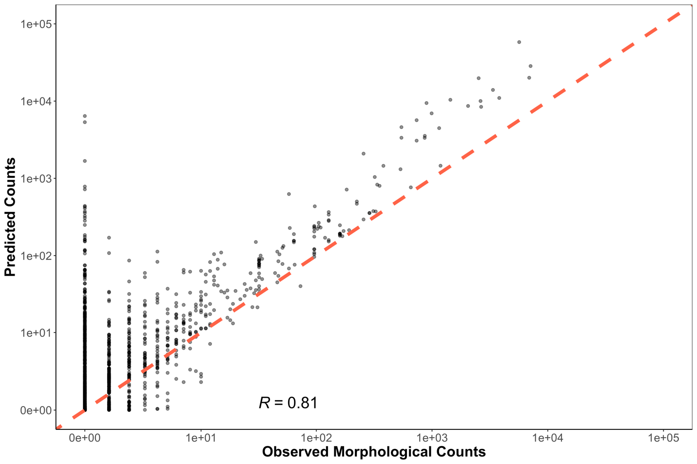

**Figure S1. Predicted Counts vs. Observed Morphological Counts**

Predicted counts are generated from the joint Bayesian model. The one-to-one line is plotted in red and Pearson correlation coefficient is 0.81. Variance in predicted counts markedly decreases with higher observed morphological counts. We note variance in predicted counts is substantially less than that between observed reads and morphological counts Figure S3.

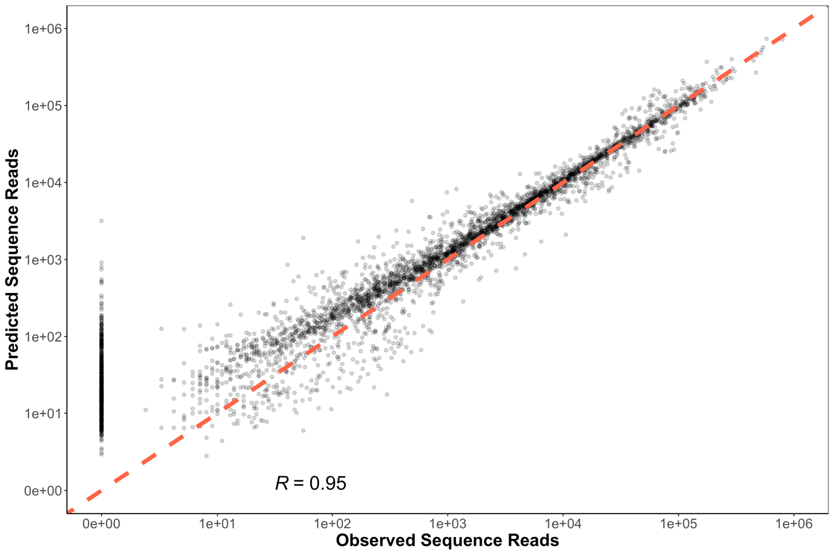

**Figure S2. Predicted Sequence Reads vs. Observed Sequence Reads**

Predicted sequence reads are generated from the joint Bayesian model. The one-to-one line is plotted in red and Pearson correlation coefficient is 0.95. In general, predicted sequence reads track observed sequence reads, and show substantially less variance than raw observed sequence reads in Figure S3. However, unexpected zeros in technical replicates or stochastic dropouts, deviate notably from expected results (points along Y-axis). We note that all observed stochastic dropouts occur in less than 1.3% of total sample proportions and less than 5 morphological counts. Such dropouts are likely a function of subsampling error associated with molecular biology processing (See Supplement 2).

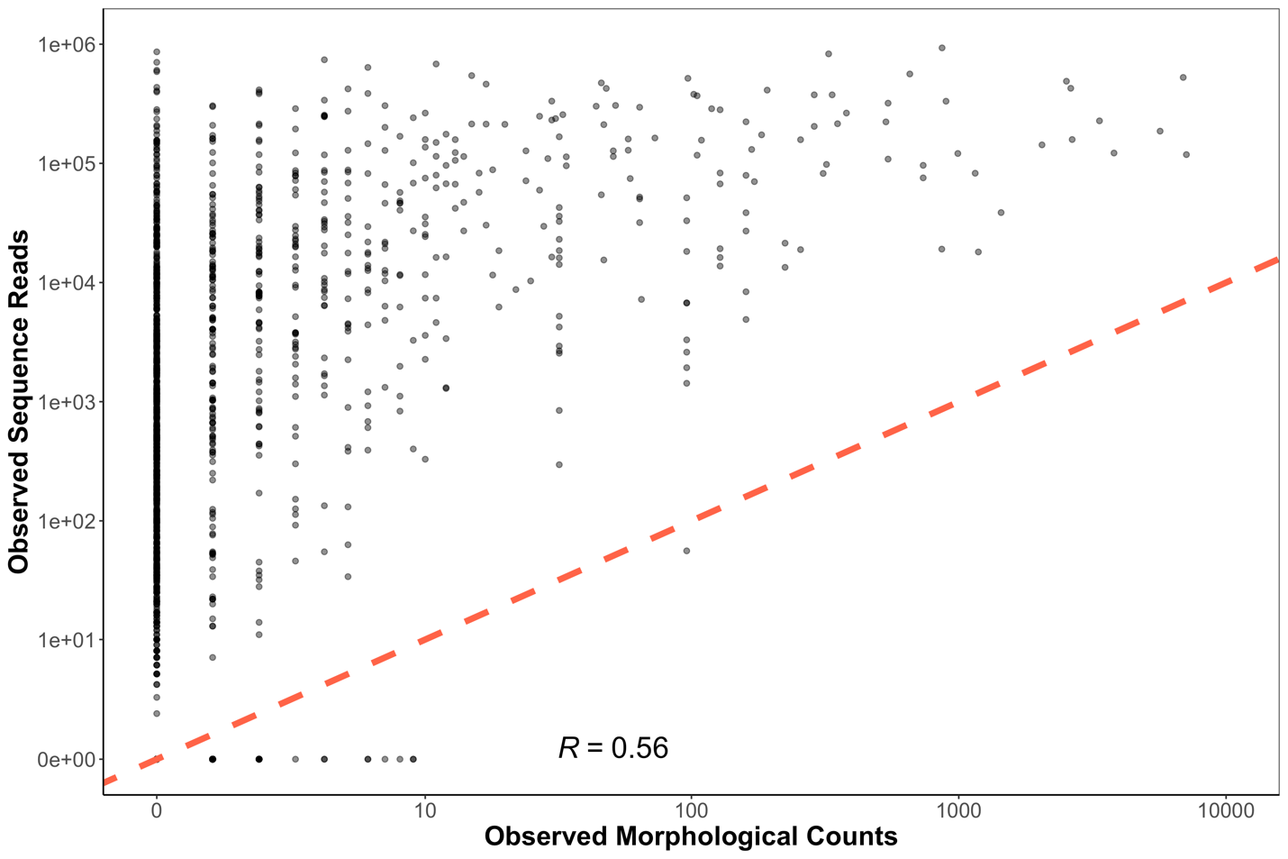

**Figure S3. Observed Sequence Reads vs. Observed Morphological Counts**

Observed sequencing reads and morphological counts do not follow a clear linear relationship. The one-to-one line is plotted in red and Pearson correlation coefficient is 0.56. Given the exponential and compositional nature of the governing PCR process, such non-linearity is unsurprising. We note the occurrence of stochastic dropouts along the X axis. We also note that variance is highest at low observed morphological counts.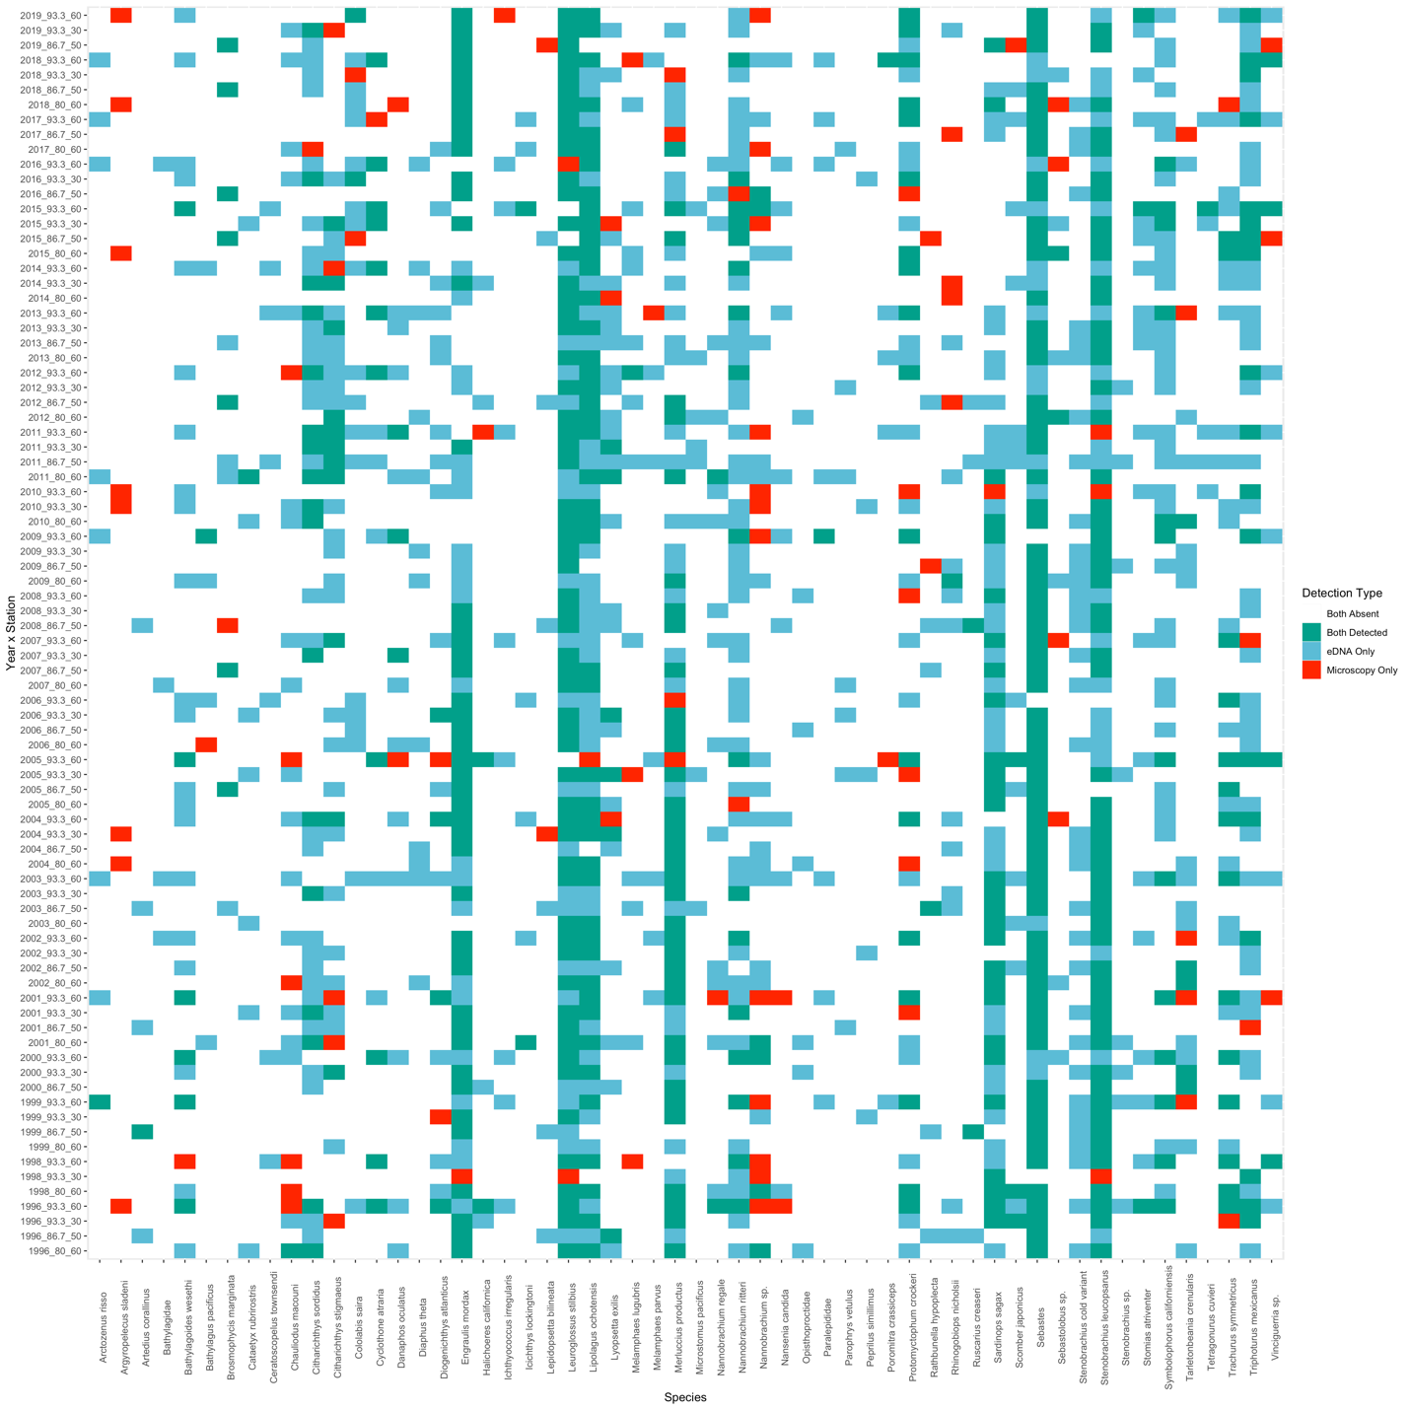

**Figure S4. Co-detection of Taxa By Metabarcoding and Microscopy**

Of the 56 taxa used for modeling efforts, both metabarcoding and microscopy both detected 46 taxa. Metabarcoding uniquely detected 9 taxa while microscopy detected a single taxa. The maximum observed morphological counts in which metabarcoding failed to detect a given taxa was 9 (mean = 1.61). Across a total of 4,704 possible detections, 70.2% were non-detections by both methods, 11.2% were detections by both methods, 16.4% were detections only made by eDNA, and 2.1% were detections only made my microscopy.

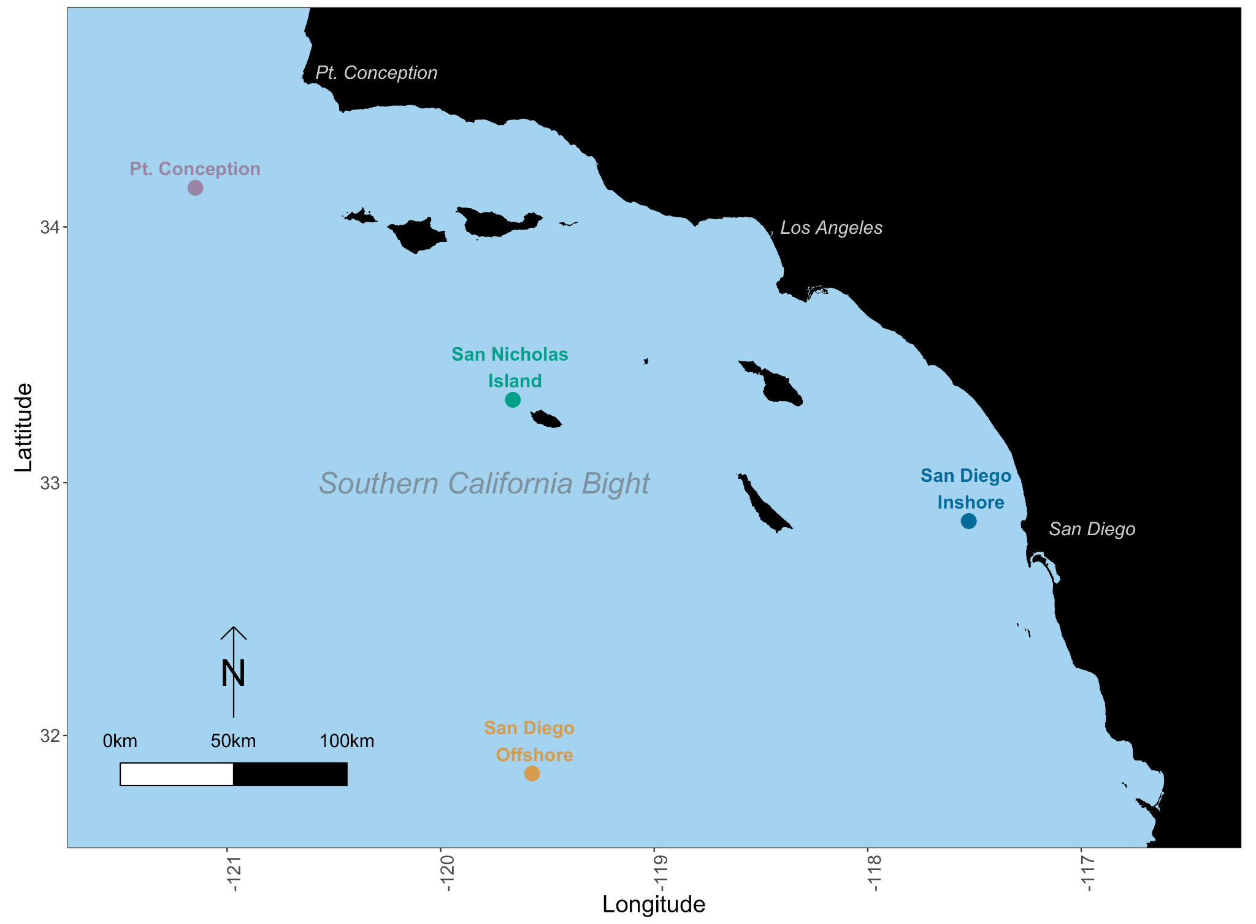

**Figure S5. Site Map**

Ichthyoplankton samples were collected from four distinct stations with variable water properties. The northernmost station was located in the California Current (34.14833˚N -121.1567˚W) offshore of Point Conception, CA. A second station was chosen off of San Nicholas Island, CA (33.32333 ˚N, -119.6667˚W) that experiences high variation in annual temperature depending on the respective strengths of the California Current and Southern California Counter Current (*64*). We also chose a Southern coastal inshore site off San Diego, CA (32.84667˚N, -117.5383˚W) which is typically characterized by warmer waters from the California Counter Current but also experiences seasonal upwelling. Lastly, we chose a southern offshore site (31.85000˚N, -119.5683˚W) which is characterized by sub-tropical oceanic waters.

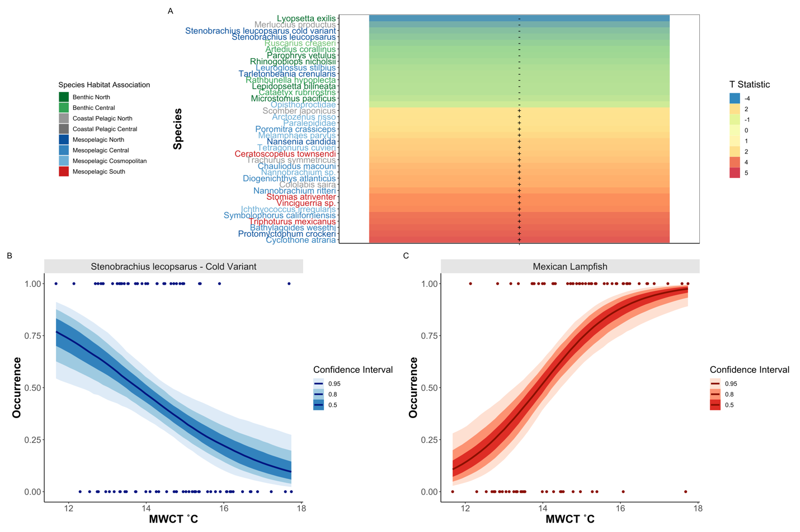

**Figure S6. Temperature Associations in Fish Species**

We capture changes in species occurrence patterns in response to MWCT, with Southern Mesopelagic species increasing in prevalence with elevated temperature (A). T statistic (slope coefficient/ standard error) from generalized binomial mixed model was calculated for each species across all sites. Only species with significantly different slopes (95% CI greater or less than zero) are plotted. Importantly, metabarcoding identified cold associated variants of the Northern Lanternfish (*Stennobrachius leucopsarus*) which cannot be morphologically identified (B) as well as warm-associated species like the Mexican Lampfish (*Triphoturus mexicanus*) (C).

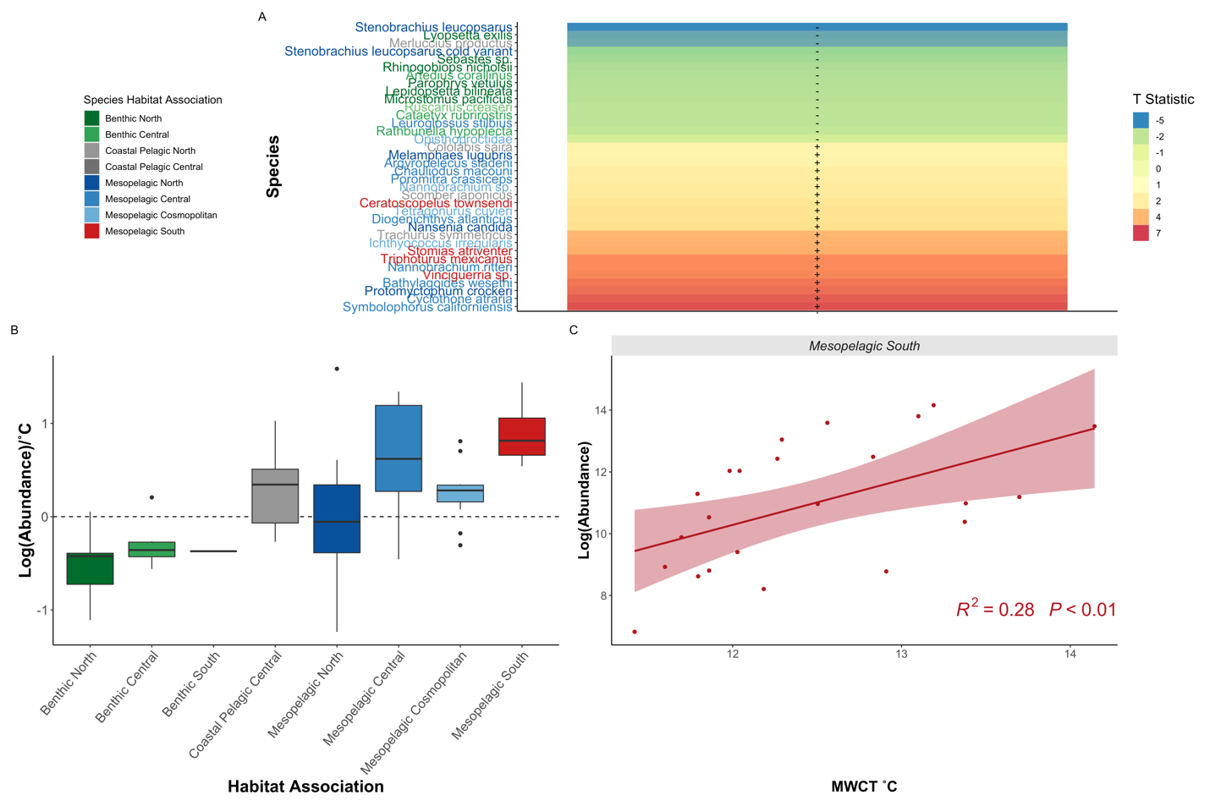

**Figure S7. Southern Oceanic Species Drive Fish Community Shifts**

We capture changes in species biomass in response to MWCT, with Southern Mesopelagic species increasing in abundance with elevated temperature (A). T statistic (slope coefficient/standard error) from generalized linear models were calculated for each species across all sites. Only species with significantly different slopes (95% CI greater or less than zero) are plotted. Southern mesopelagic fishes were associated with increased temperature as indicated by the boxplots of all species-specific slopes from generalized linear models (B) and by the aggregated abundance relationship (C). In contrast, benthic species, as well as Northern Hake and Pacific Sardine abundances, were correlated with cooler temperatures.

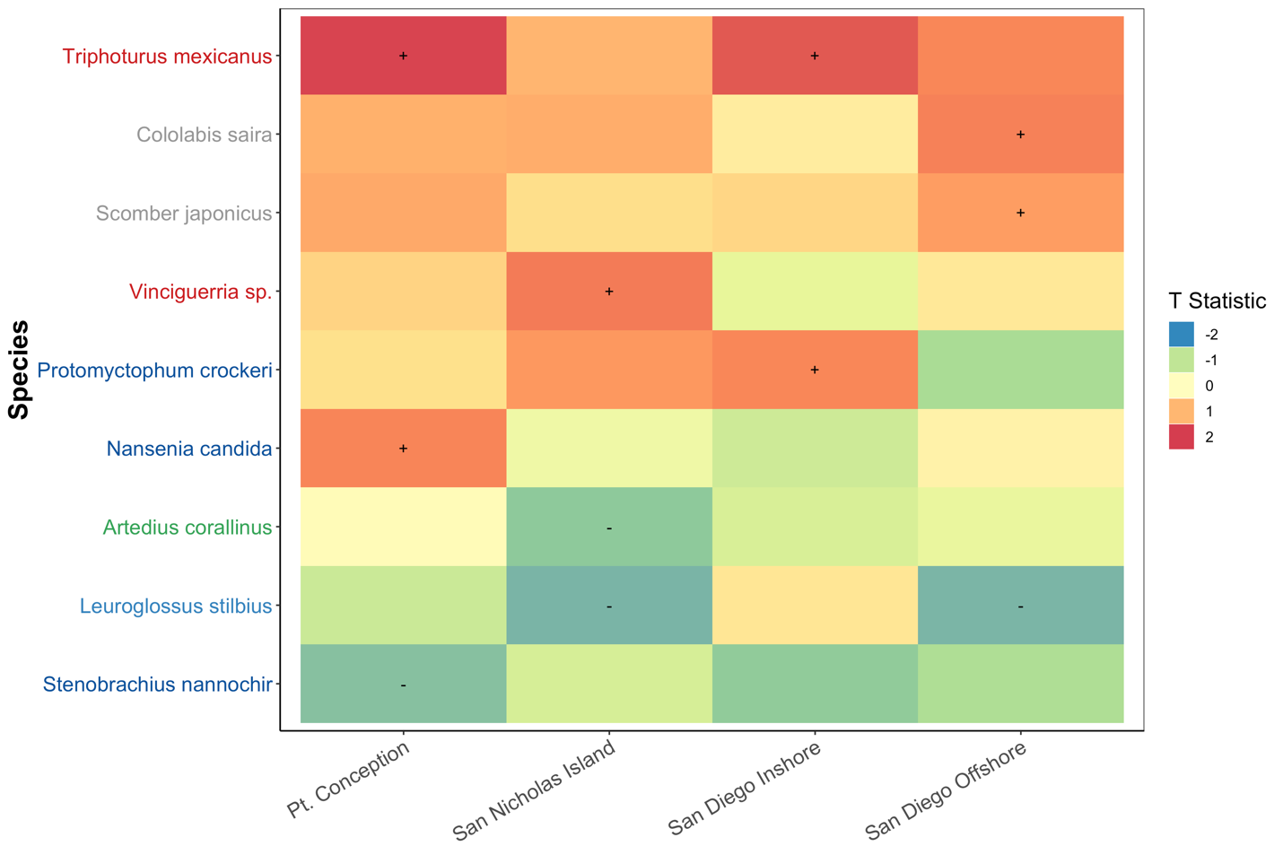

**Figure S8. Significant Species Occurrence and SST Correlations at each Site**

Occurrence of the Mexican lampfish (*Triphoturus mexicanus*)was positively correlated with increased SST at the three northernmost sites. Generalized binomial mixed model of occurrence versus SST was calculated for each species at each site. Only species with significantly different slopes (95% CI greater or less than zero) are plotted. Colors correspond to T statistic (slope coefficient/ standard error). Colors of species names correspond to habitat associations described in Figure 2.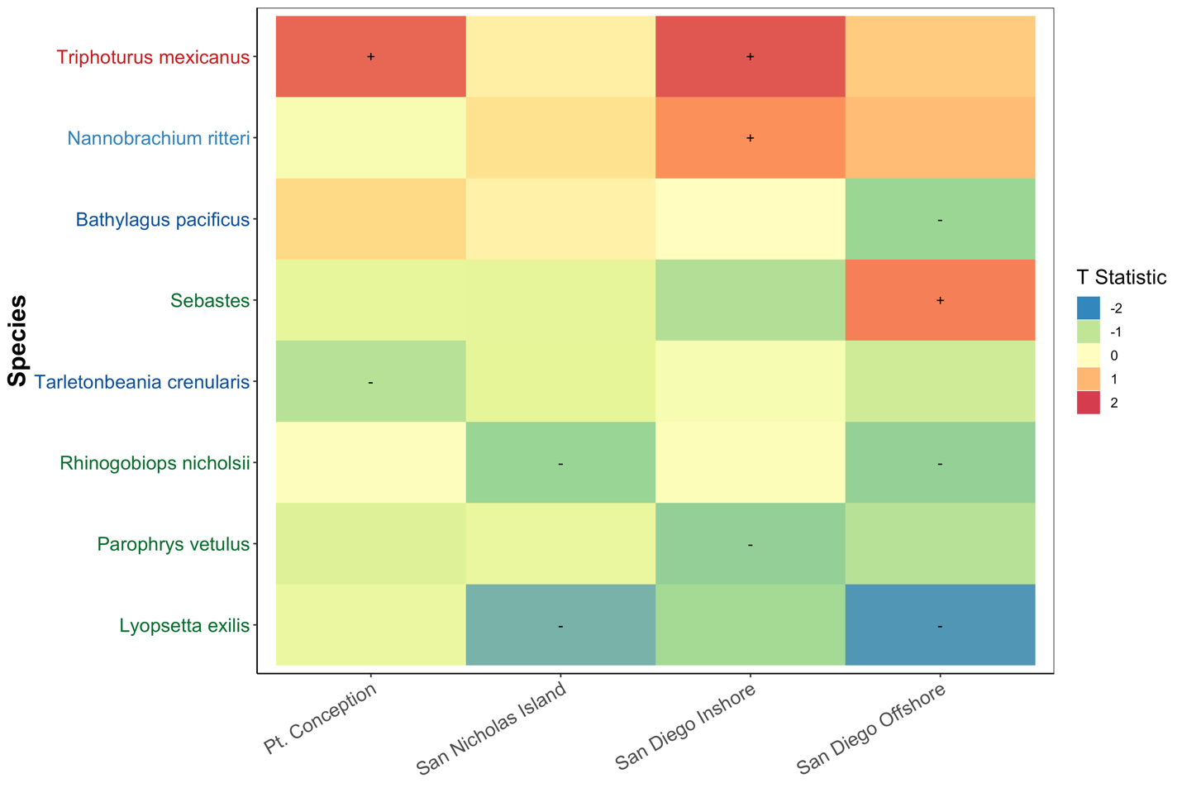

**Figure S9. Significant Species Occurrence and MWCT Correlations at each Site**

Occurrence of the Mexican lampfish (*Triphoturus mexicanus*)was positively correlated with increased MWCTat the three northernmost sites. Generalized binomial mixed model of occurrence versus MWCTwas calculated for each species at each site. Only species with significantly different slopes (95% CI greater or less than zero) are plotted. Colors correspond to T_statistic (slope coefficient/ standard error). Colors of species names correspond to habitat associations described in Figure 2.

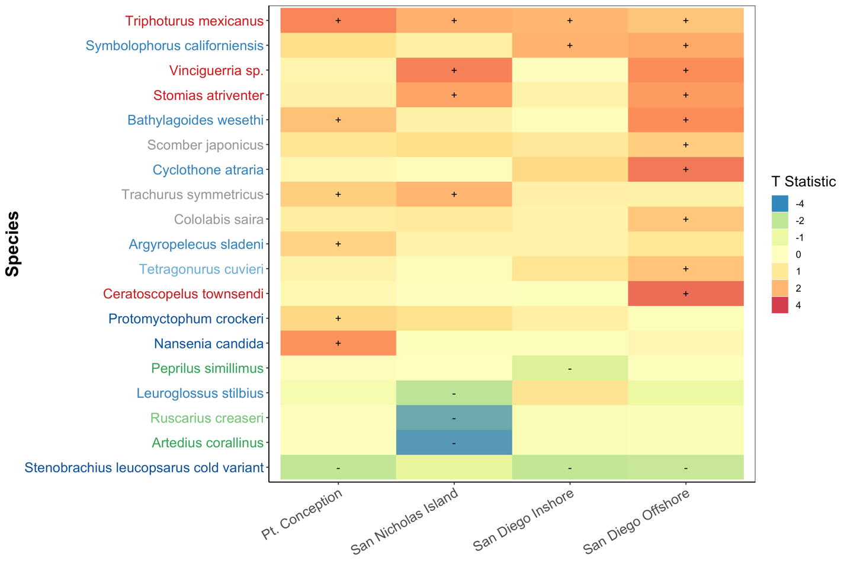 **Figure S10. Significant Species Abundance and SST Correlations at each Site**

The bbundance of the Mexican lampfish (*Triphoturus mexicanus*)was positively associated with increased SST at all sites. Likewise, the abundance of suite of mesopelagic species including *Vinciguerria* sp., *Symbolophorus californiensis,* and *Stomias atriventer* among others increased with warmer SST. Generalized linear mixed model of log (abundance) versus SST was calculated for each species at each site. Only species with significantly different slopes (95% CI greater or less than zero) are plotted. Colors correspond to T statistic (slope coefficient/ standard error). Colors of species names correspond to habitat associations described in Figure 2.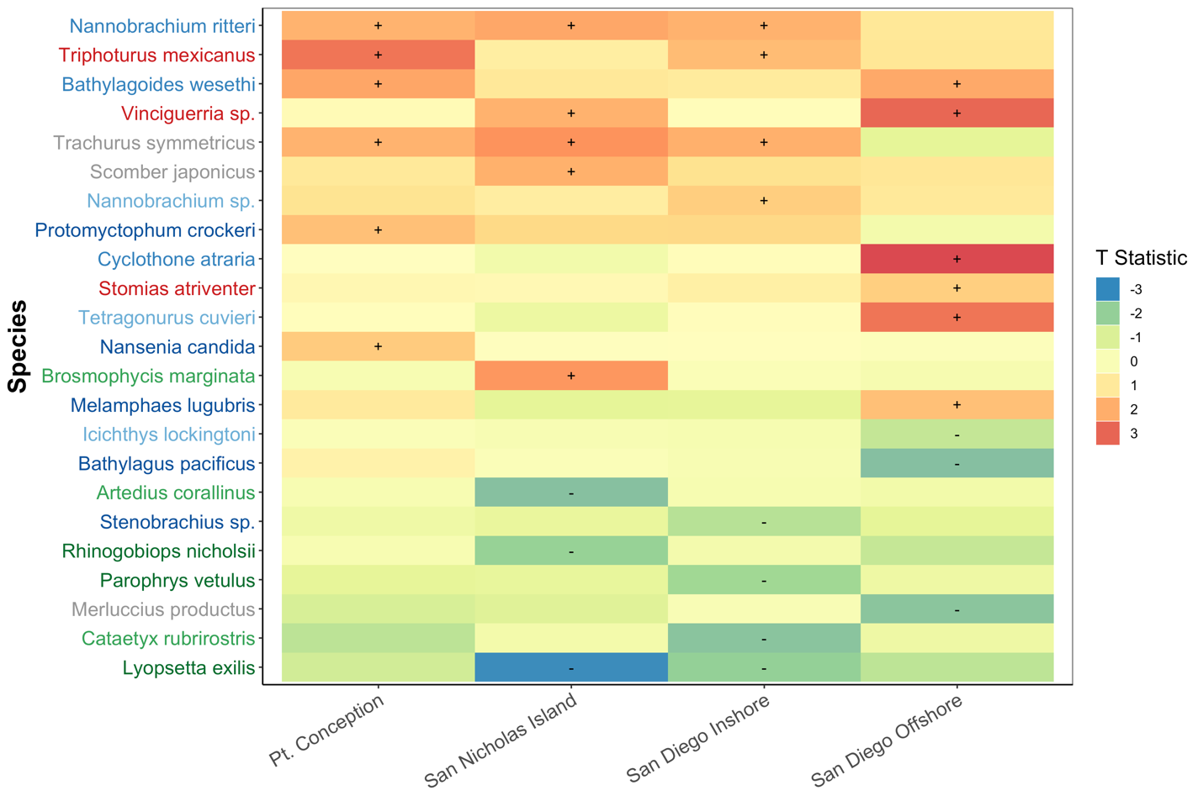

**Figure S11. Significant Species Abundance and MWCT Correlations at each Site**

The abundance of the Mexican lampfish (*Triphoturus mexicanus*)was positively associated with increased MWCTat all sites. Likewise, the abundance of suite of mesopelagic species including *Vinciguerria* sp., *Symbolophorus californiensis,* and *Stomias atriventer* among others increased with warmer SST. Generalized linear mixed model of log (abundance) versus MWCTwas calculated for each species at each site. Only species with significantly different slopes (95% CI greater or less than zero) are plotted. Colors correspond to T statistic (slope coefficient/ standard error). Colors of species names correspond to habitat associations described in Figure 2.

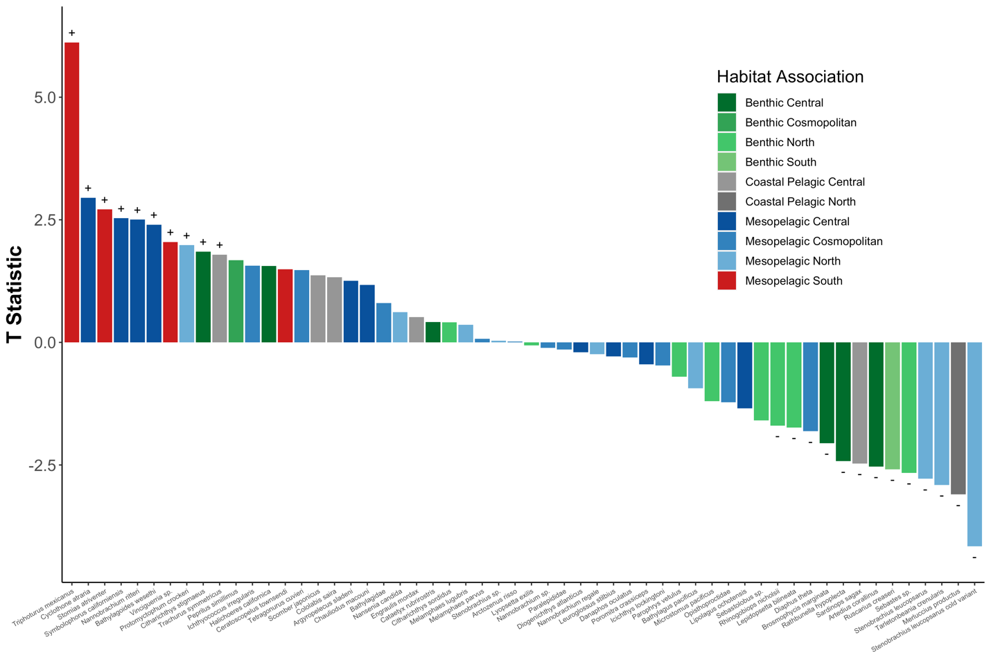

**Figure S12.** **Bar Plot** **of Significant Species Abundance and SST Correlations Across All Sites**

The abundance of southern mesopelagic species increased with warmer temperatures while fisheries targets like Pacific Sardine (*Sardinops sagax*) and North Pacific Hake (*Merluccius productus*) decreased. Generalized linear mixed model of log (abundance) versus SST was calculated for each species across all sites. Only species with significantly different slopes (95% CI greater or less than zero) are plotted. Colors correspond to T statistic (slope coefficient/ standard error).

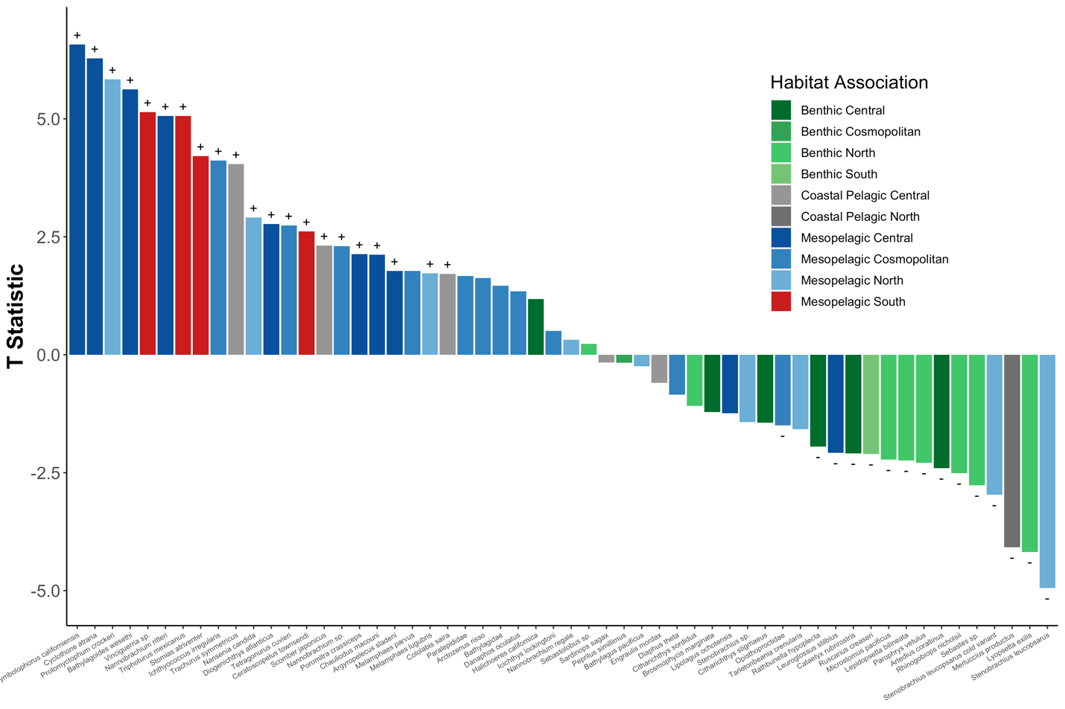

**Figure S13.** **Bar Plot** **of Significant Species Abundance and MWCT Correlations Across All Sites**

The abundance of southern mesopelagic species increased with warmer temperatures while fisheries targets like Pacific Sardine (*Sardinops sagax*) and North Pacific Hake (*Merluccius productus*) decreased. Generalized linear mixed model of log (abundance) versus SST was calculated for each species across all sites. Only species with significantly different slopes (95% CI greater or less than zero) are plotted. Colors correspond to T statistic (slope coefficient/ standard error).

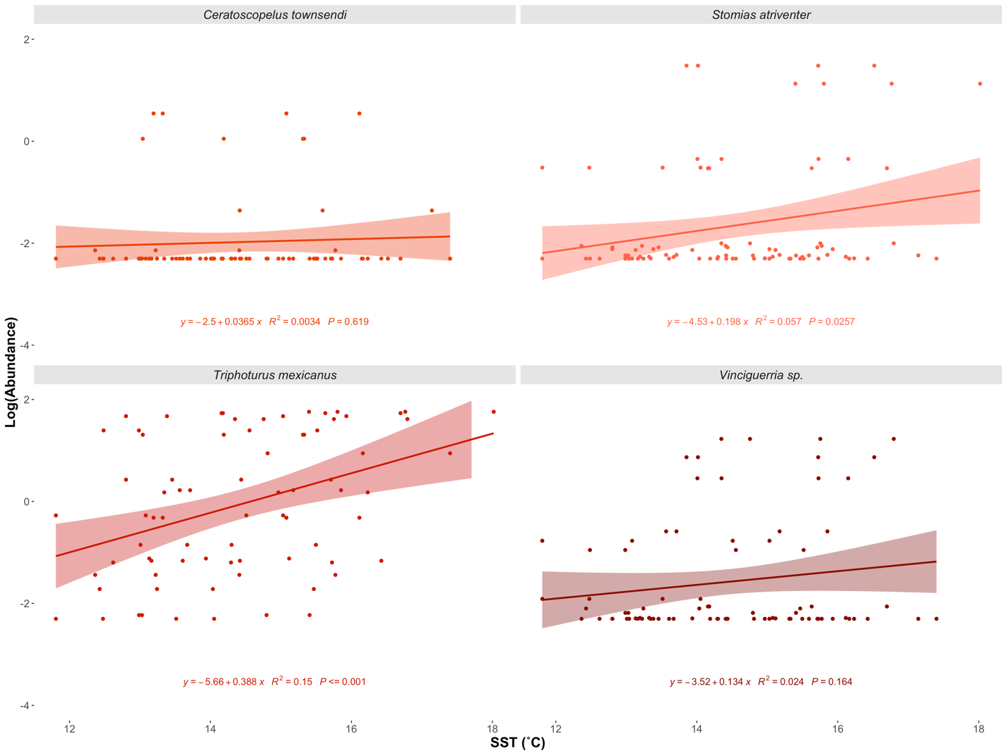

**Figure S14. Increased Abundance of Southern Mesopelagic Species with Higher SST**

Species specific regressions of log (Abundance) vs. SST (˚C). Three of the four southern mesopelagic species had significant positive associations between abundance and SST. Although not significant across all sites, the abundance of *Ceratoscopelus townsendi* significantly increased with higher SST at the San Diego Offshore site (Figure S7).

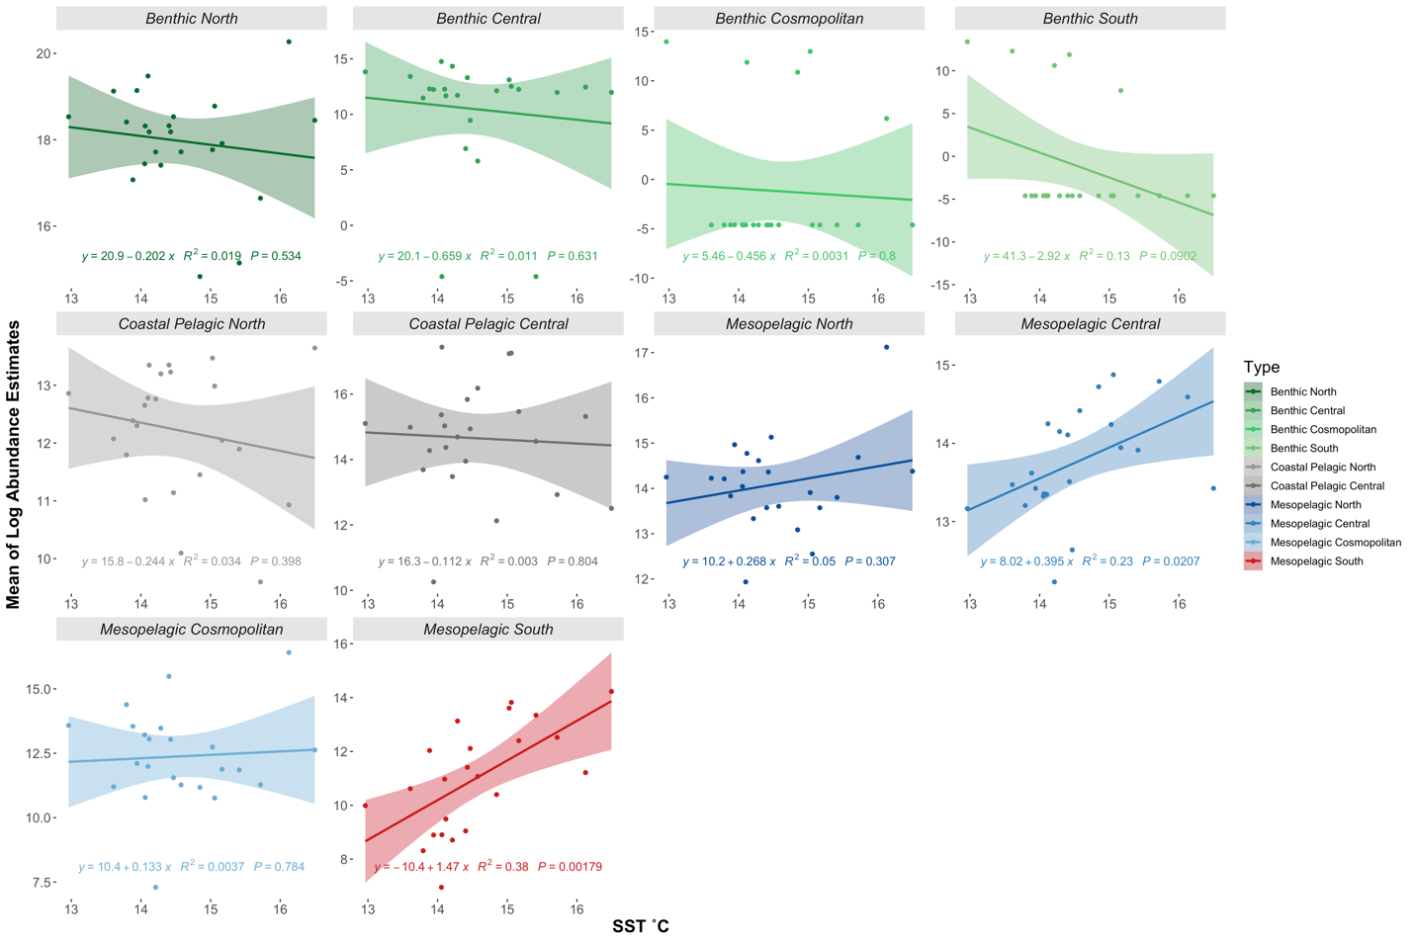

**Figure S15. Increased Abundance of Southern and Central Mesopelagic Species with Higher SST**

Abundances of each habitat association were summed at each site. Habitat association regressions were fit using sum total log (Abundance) vs. SST (˚C).

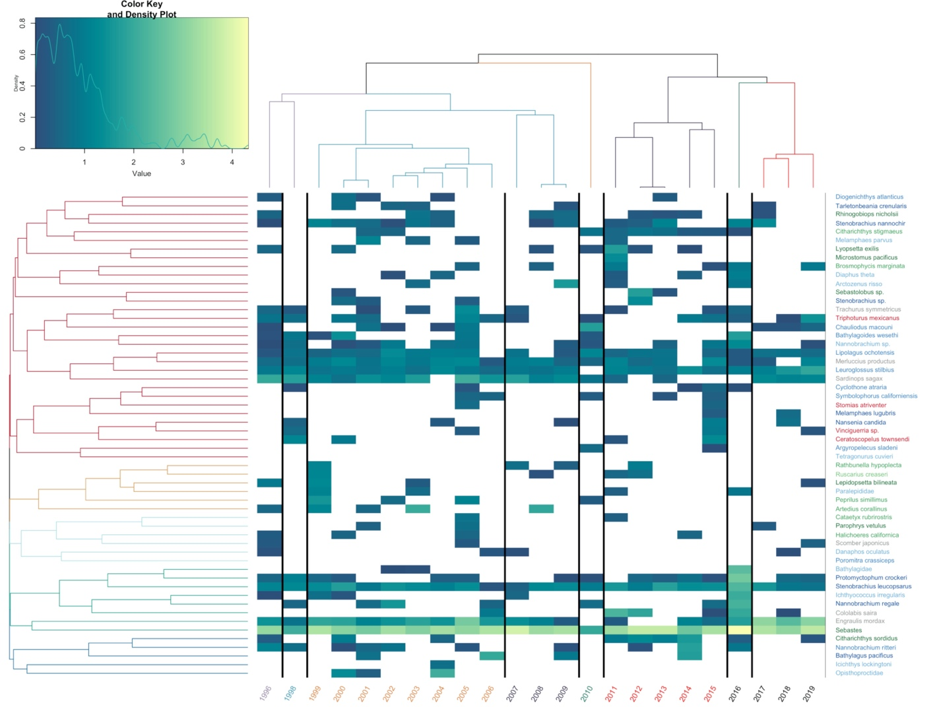

**Figure S16. Heat Map of Abundances Over Time**

Northern Anchovy (*Engraulis* mordax) and rockfishes *Sebastes* sp. dominated predicted counts. Estimated abundance of each year, averaged across sites, plotted over time. Years are color coded by chronological clustering. Species are grouped by hierarchical clustering. Lighter colors indicate higher abundance, white is a lack of detection. Species are color coded by habitat association matching Figure 1.

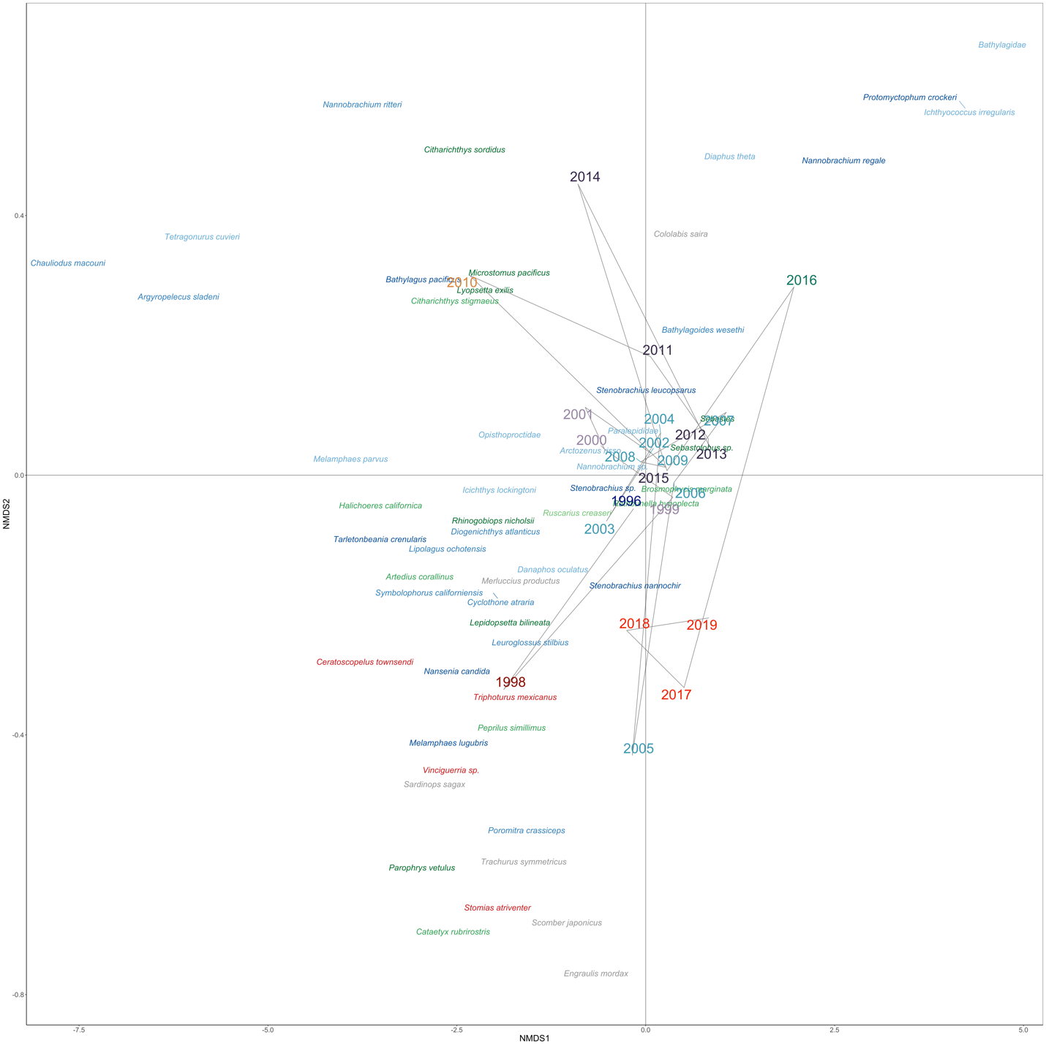

**Figure S17. NMDS Ordination of Species and Years**

Fish assemblages changed across time with southern mesopelagics clustering with the 1998 and 2005 El Niños as well as 2017-2019 after the peak of the marine heat wave. NMDS Ordination of Bray-Curtis dissimilarities calculated from summed abundance of each year averaged across sites. Marine heatwave patterns are obscured by differential onset and receding of the warming event across sites. Years are color coded by chronological clustering (k =8). Species are color coded by habitat association matching Figure 2.

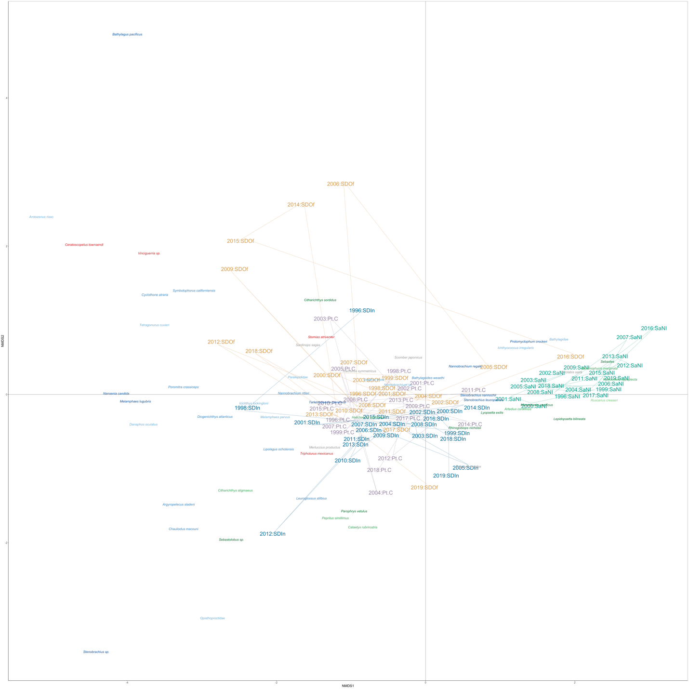

**Figure S18. NMDS Ordination of Species and Samples**

Fish assemblages were strongly structured by sites, particularly the station just offshore of San Nicholas Island which had the highest abundance of *Sebastes* sp. NMDS Ordination of Bray-Curtis dissimilarities calculated from summed abundance of each year averaged across sites. Marine heatwave patterns are obscured by differential onset and receding of the warming event across sites. Samples are color coded by station. Species are color coded by habitat association matching Figure 2.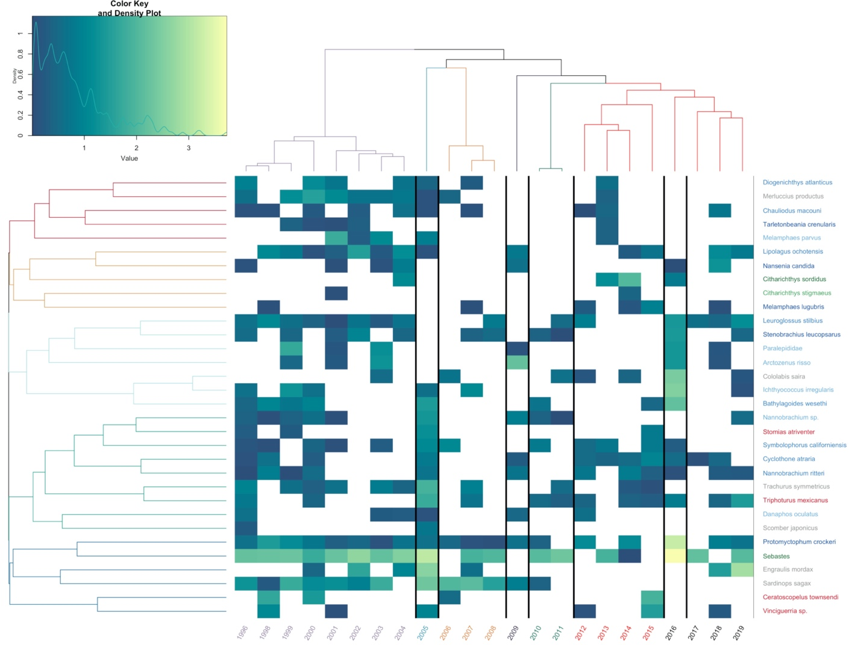

**Figure S19. Heat Map of San Diego Offshore Abundances Over Time**

Estimated abundance of each year plotted over time. Years are color coded by chronological clustering. Species are grouped by hierarchical clustering. Lighter colors indicate higher abundance, white is a lack of detection. Species are color coded by habitat association matching Figure 1.

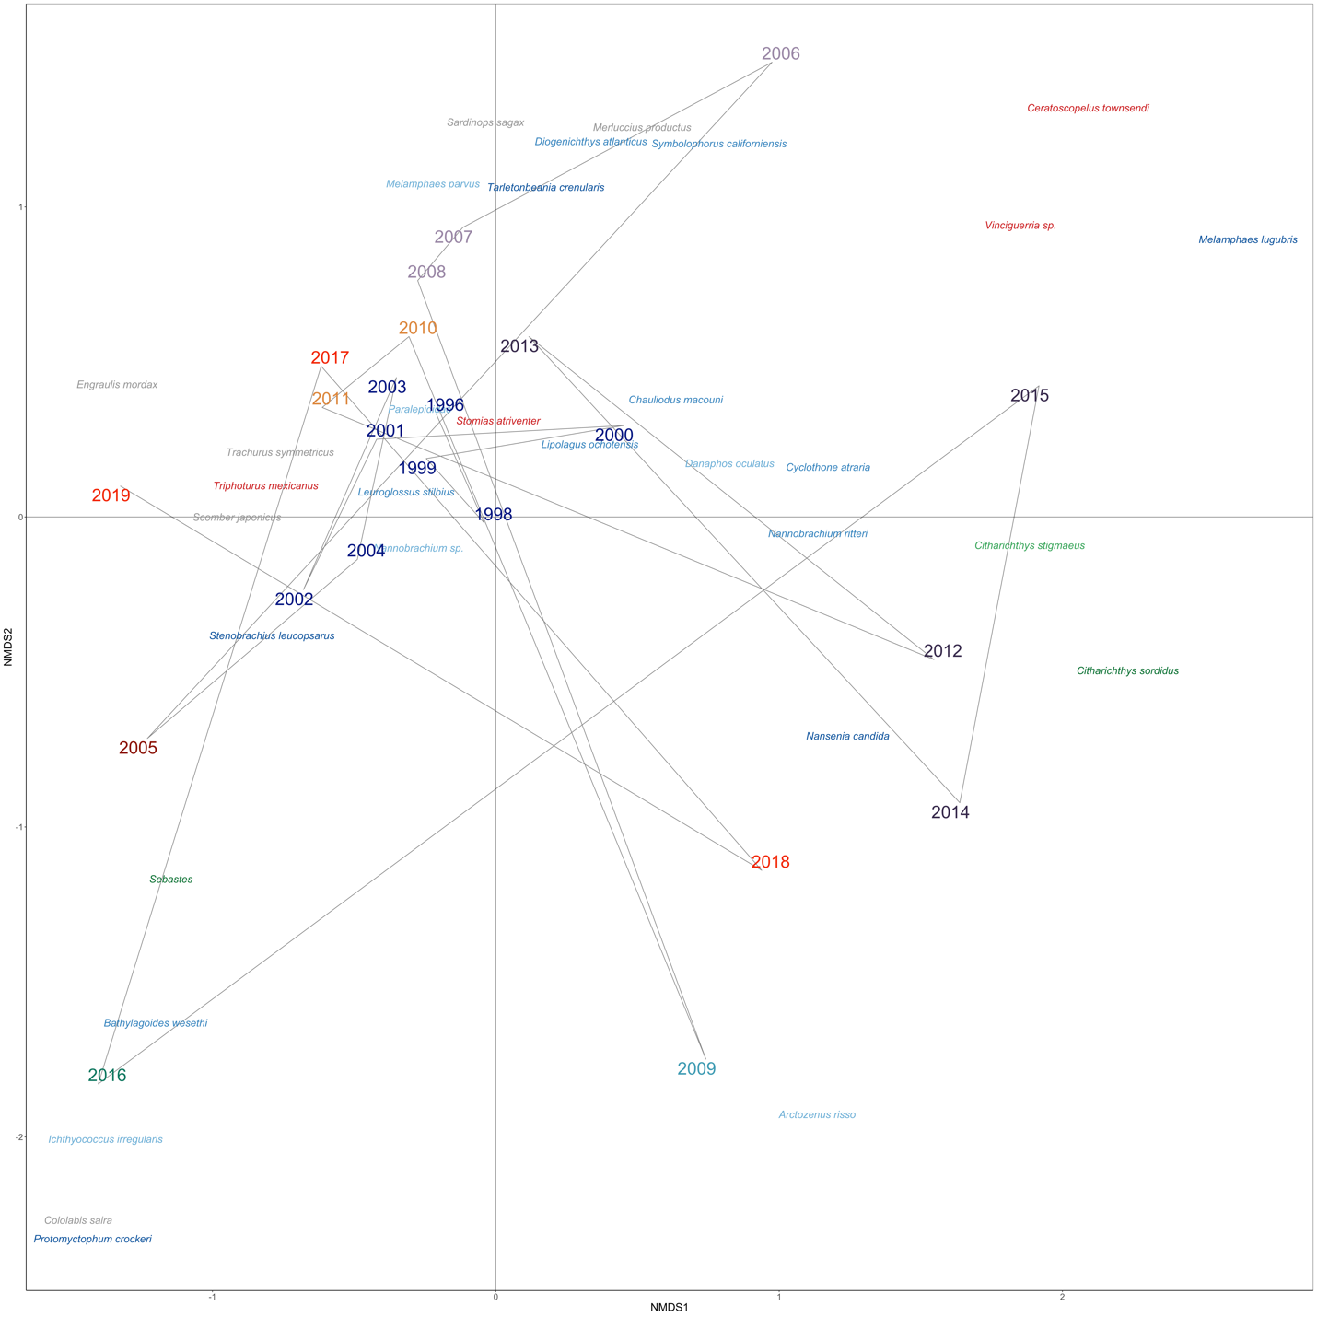

**Figure S20. NMDS Ordination of San Diego Offshore Species and Years**

NMDS Ordination of Bray-Curtis dissimilarities calculated from abundance of each year. Years are color coded by chronological clustering (k =8). Species are color coded by habitat association matching Figure 2.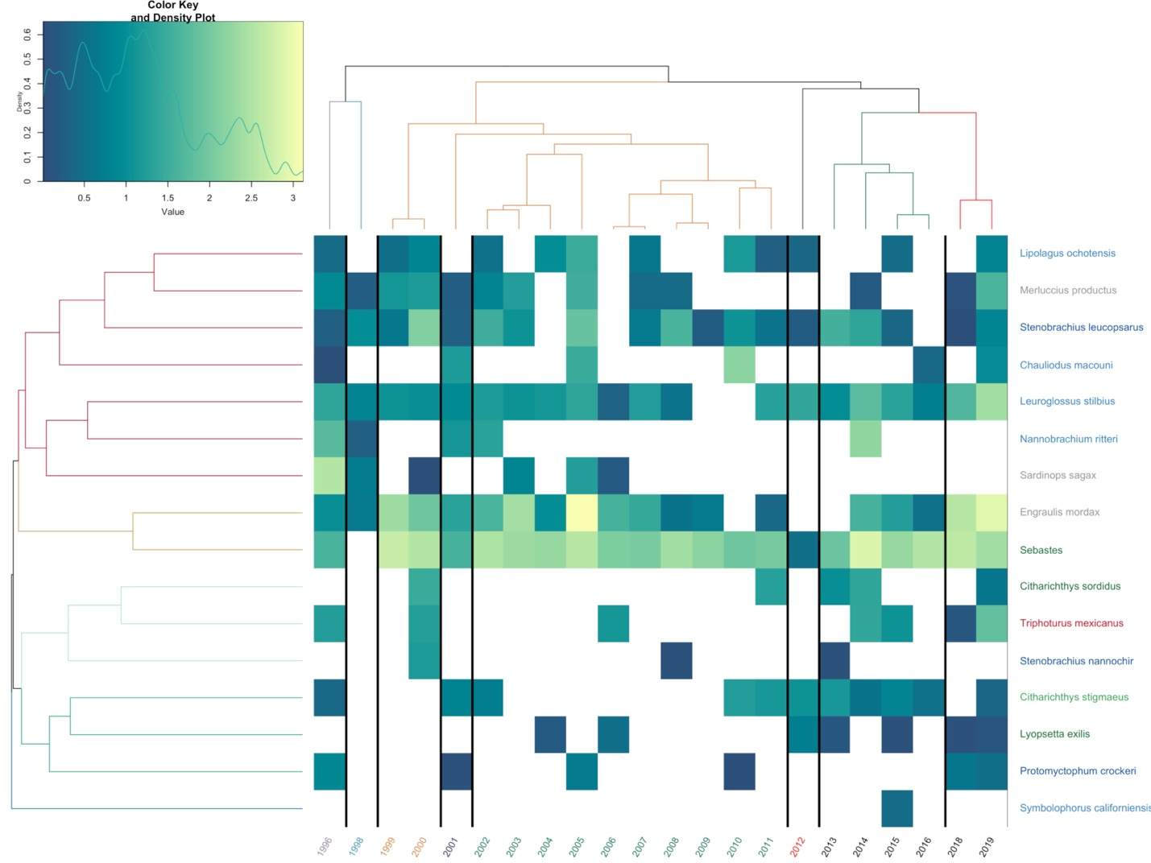

**Figure S21. Heat Map of San Diego Inshore Abundances Over Time**

Estimated abundance of each year plotted over time. Years are color coded by chronological clustering. Species are grouped by hierarchical clustering. Lighter colors indicate higher abundance, white is a lack of detection. Species are color coded by habitat association matching Figure 1.

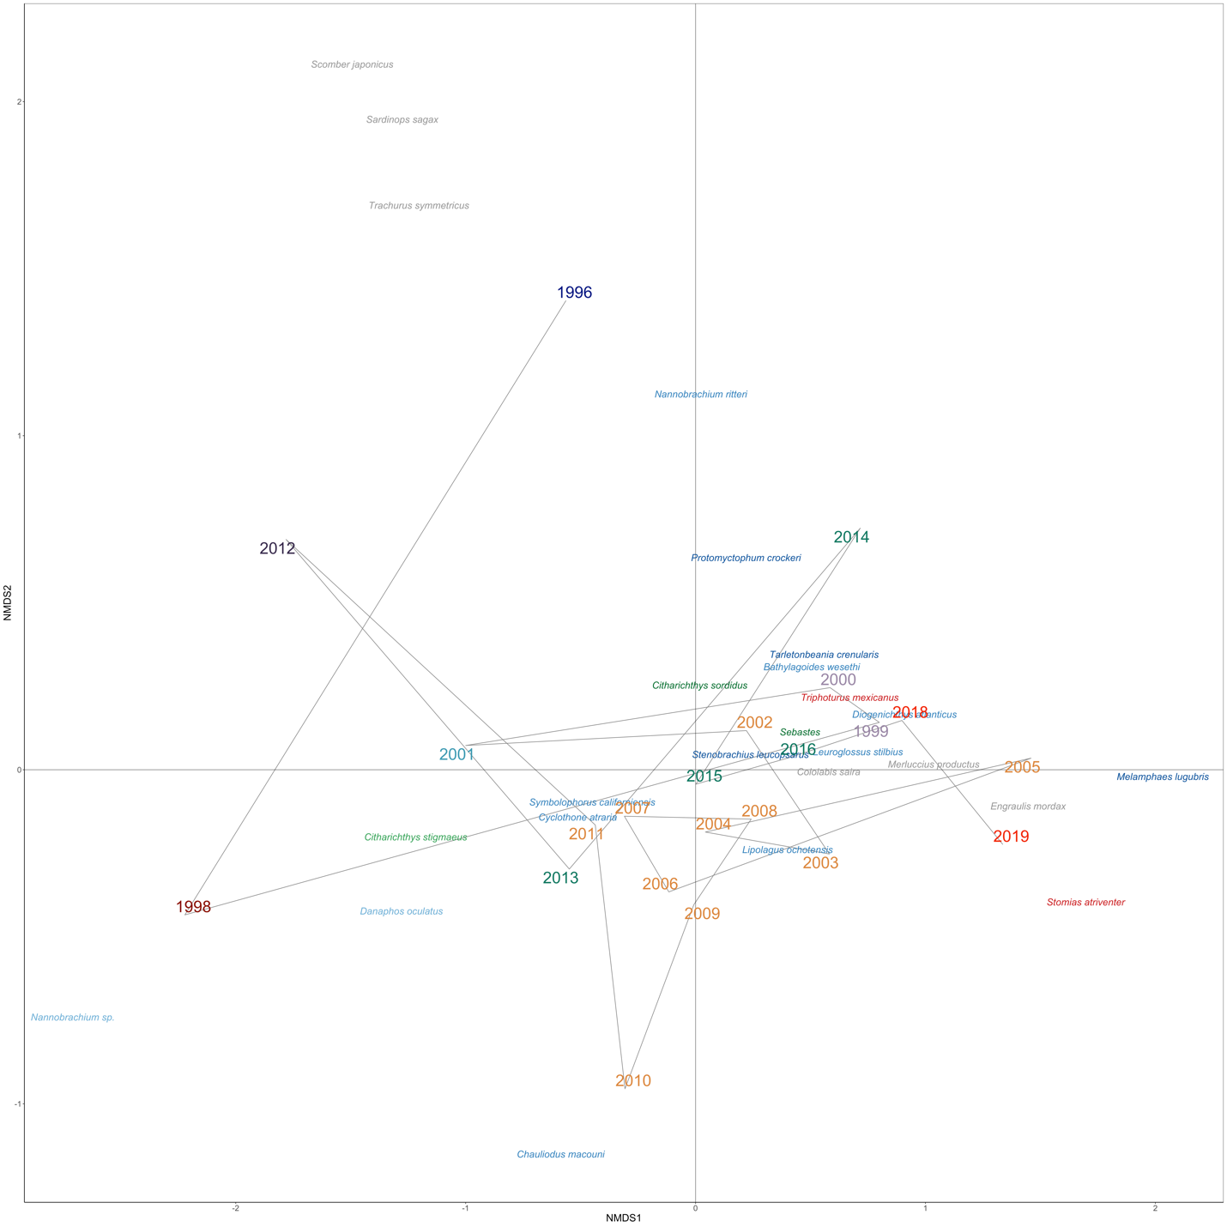**Figure S22. NMDS Ordination of San Diego Inshore Species and Years**

NMDS Ordination of Bray-Curtis dissimilarities calculated from abundance of each year. Years are color coded by chronological clustering (k =8). Species are color coded by habitat association matching Figure 2.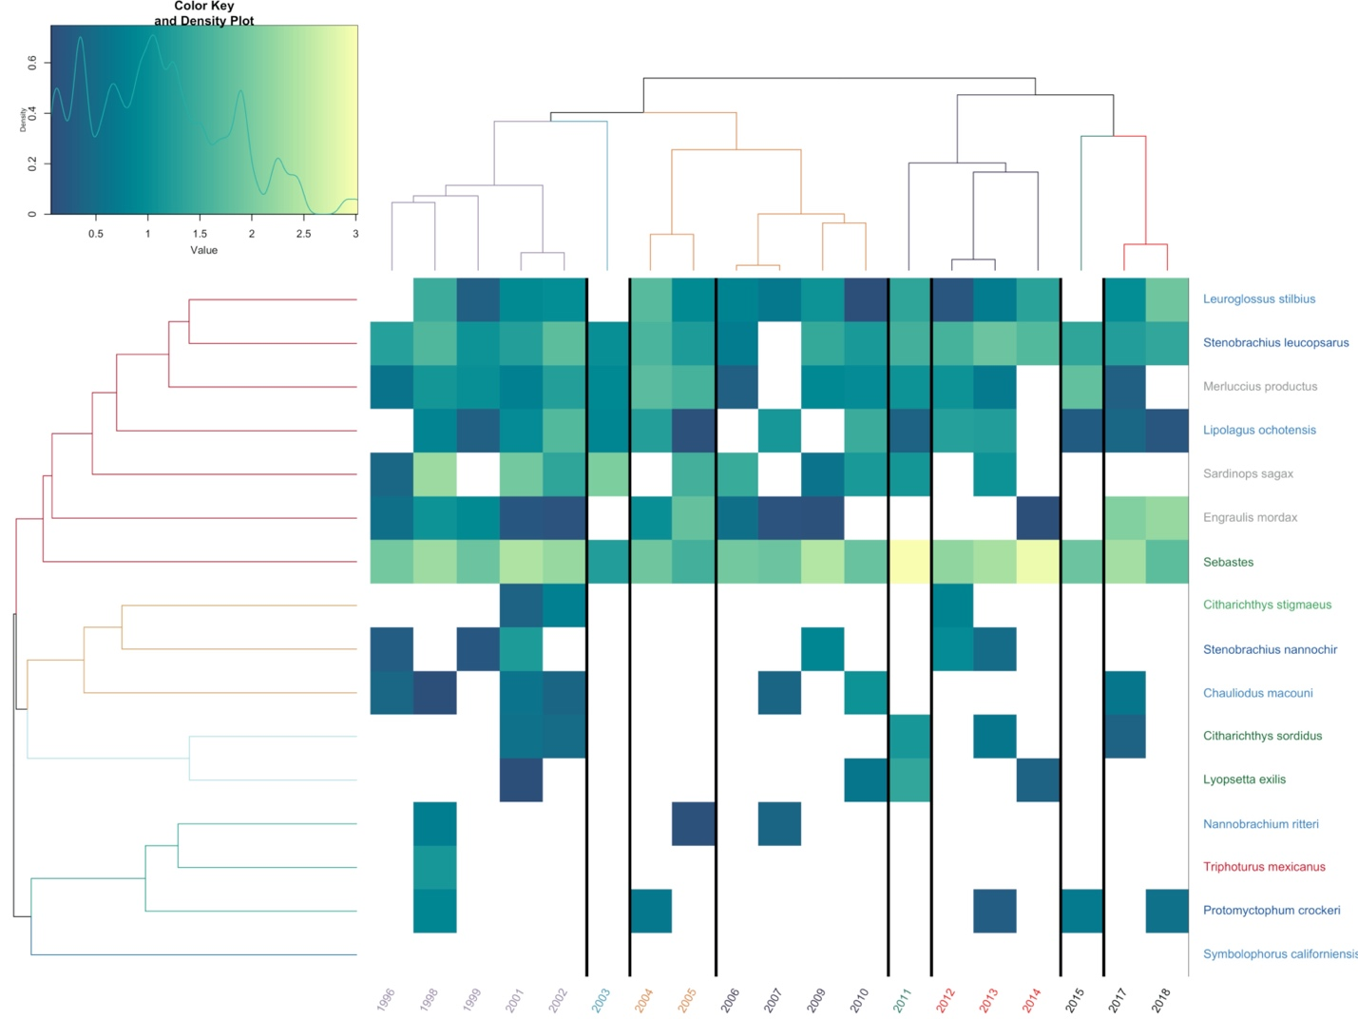

**Figure S23. Heat Map of Pt. Conception Abundances Over Time**

Estimated abundance of each year plotted over time. Years are color coded by chronological clustering. Species are grouped by hierarchical clustering. Lighter colors indicate higher abundance, white is a lack of detection. Species are color coded by habitat association matching Figure 1.

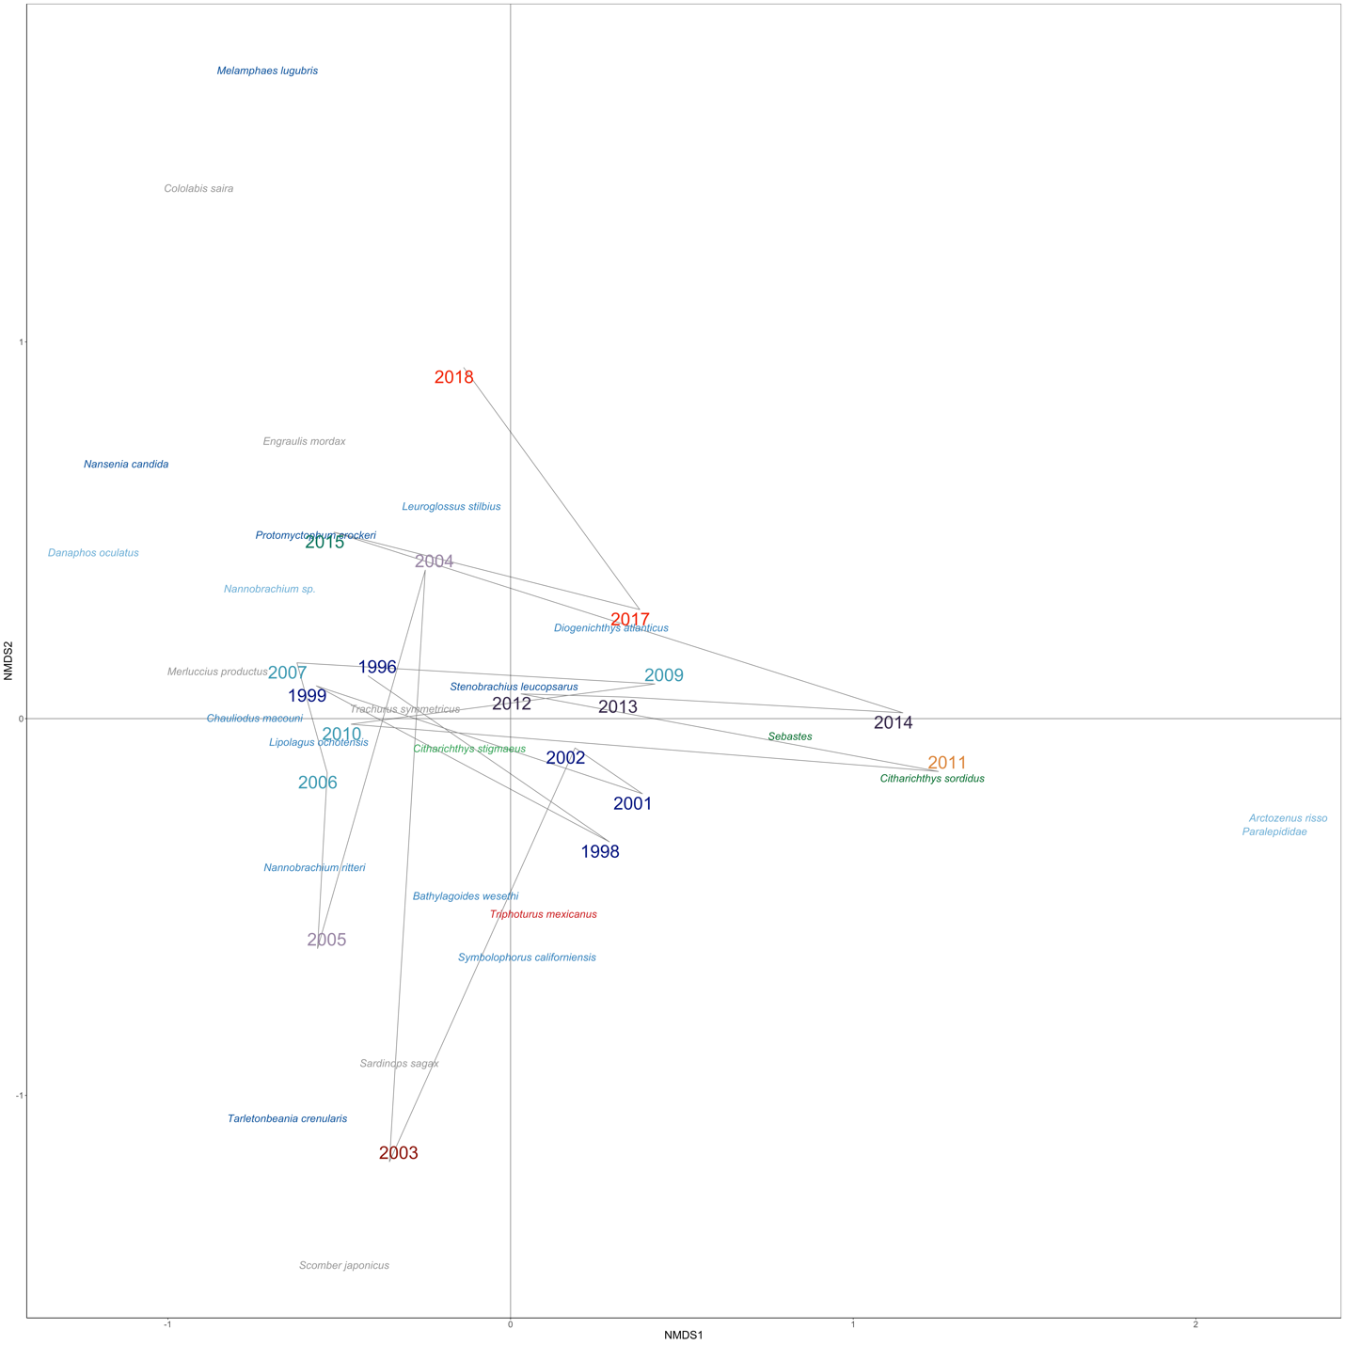

**Figure S24. NMDS Ordination of Pt. Conception Species and Years**

NMDS Ordination of Bray-Curtis dissimilarities calculated from abundance of each year. Years are color coded by chronological clustering (k =8). Species are color coded by habitat association matching Figure 2.

**Figure S25. Heat Map of San Nicholas Island Abundances Over Time**

Estimated abundance of each year plotted over time. Years are color coded by chronological clustering. Species are grouped by hierarchical clustering. Lighter colors indicate higher abundance, white is a lack of detection. Species are color coded by habitat association matching Figure 1.



**Figure S26. NMDS Ordination of San Nicholas Island Species and Years**

NMDS Ordination of Bray-Curtis dissimilarities calculated from abundance of each year. Years are color coded by chronological clustering (k =8). Species are color coded by habitat association matching Figure 2.

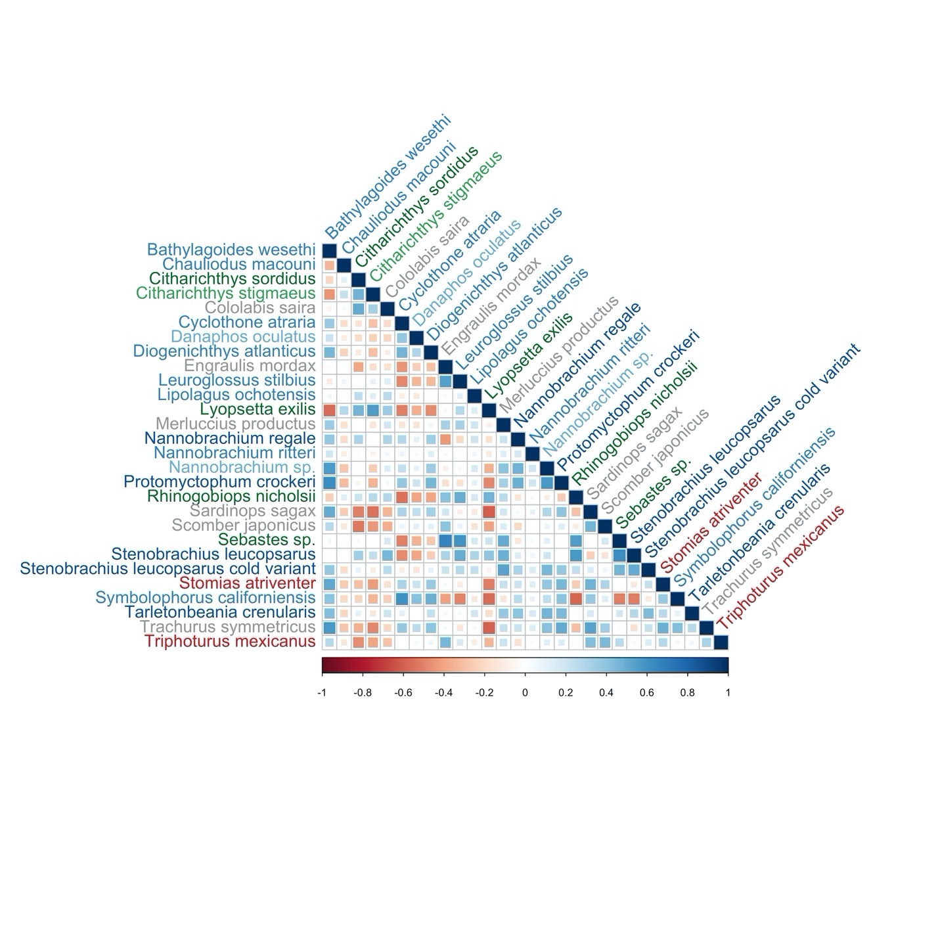

**Figure S27. Co-occurrence Patterns of Species Controlling for SST**

Benthic fisheries targets like sanddabs were negatively correlated with mesopelagic species when controlling for SST. These results capture a strong benthic vs. pelagic community dynamics when controlling for SST. We plot the correlation matrix of the generalized linear latent variable model predictors across species. Species in blue correlate are positively correlated with each other while species in red are negatively correlated. Strength of association is visualized by size of square. Species are color coded by habitat association matching Figure 2.

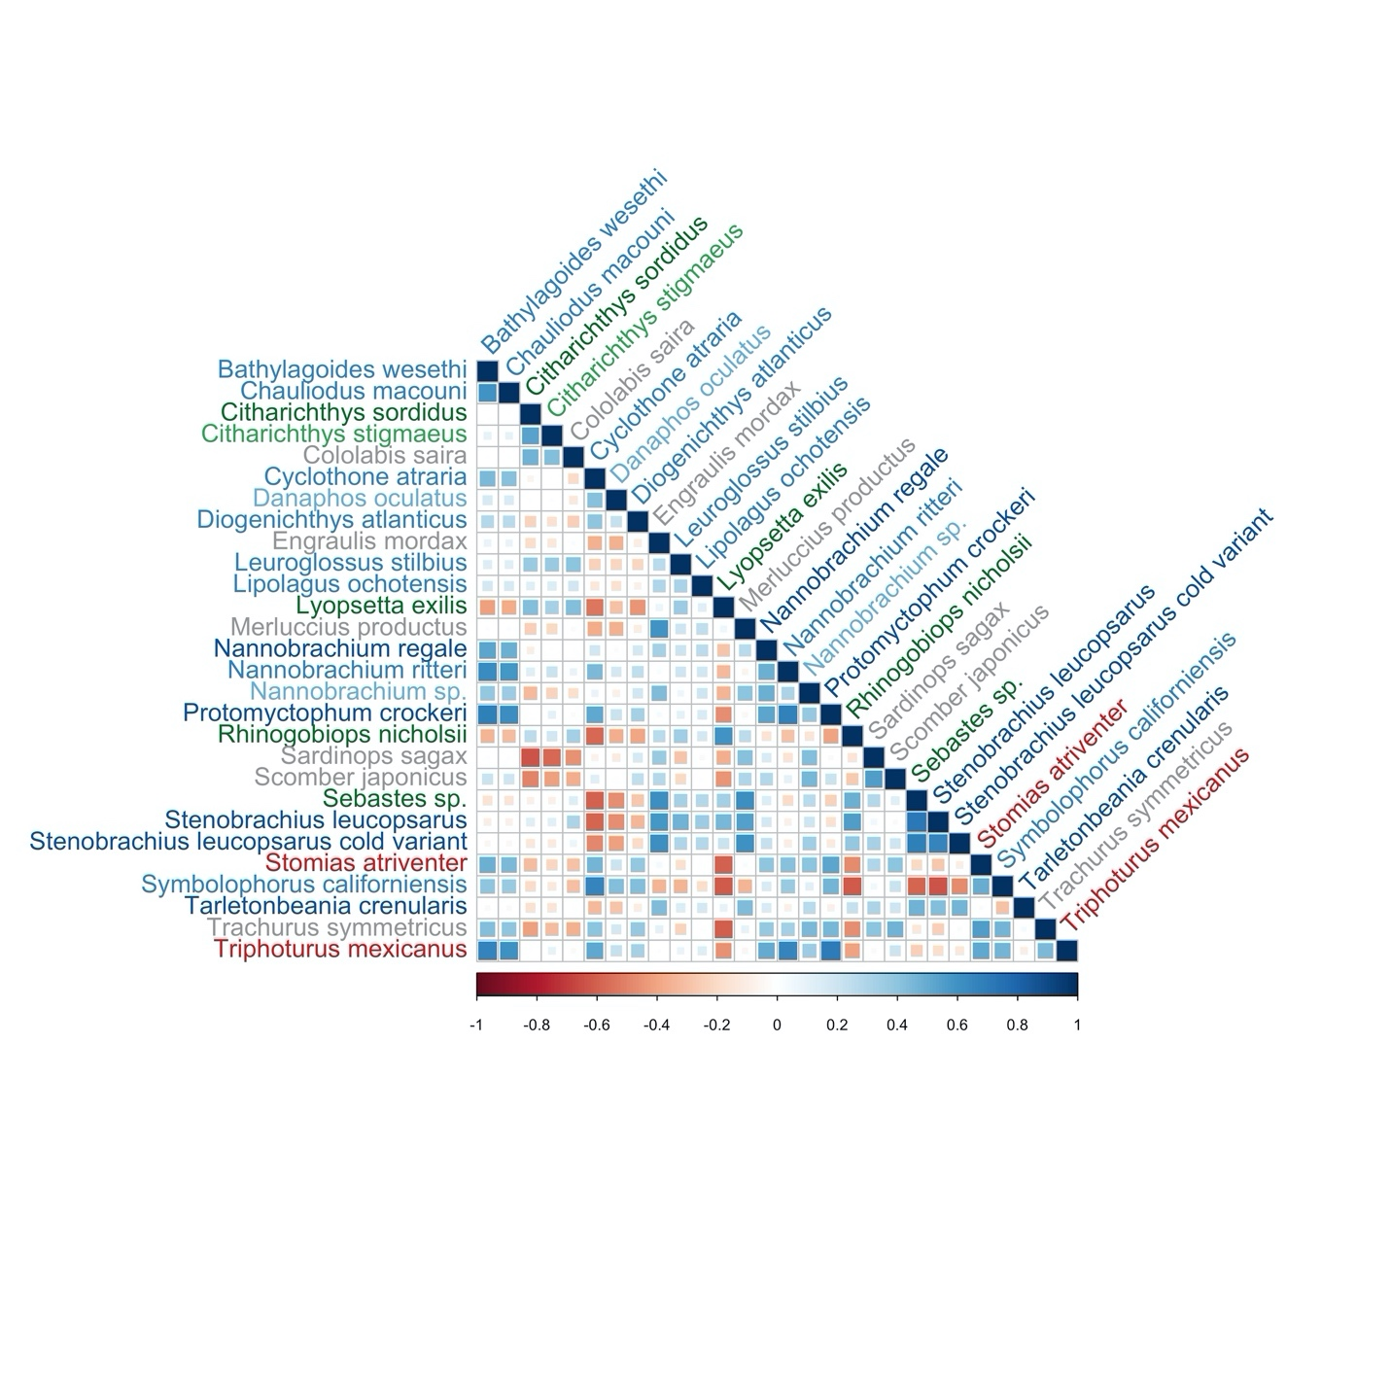

**Figure S28. Co-occurrence Patterns of Species**

Fisheries targets like North Pacific Hake were negatively correlated with mesopelagic species. We plot the correlation matrix of the generalized linear latent variable model predictors across species. Species in blue correlate are positively correlated with each other while species in red are negatively correlated. Strength of association is visualized by size of square. Species are color coded by habitat association matching Figure 2.

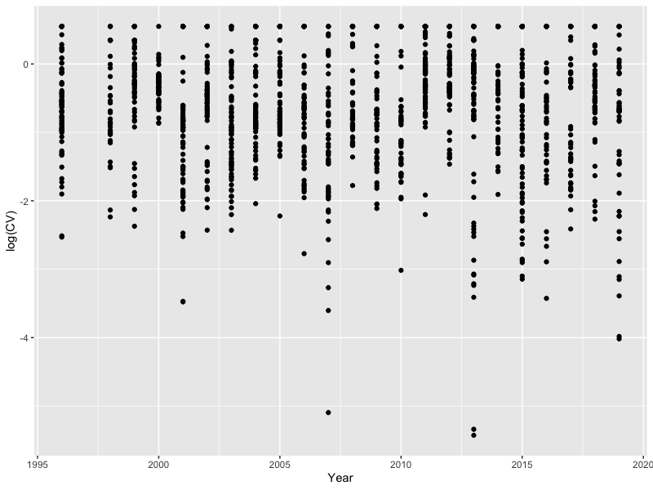

**Figure S29. Stable Precision of Amplicon Abundance Over Time**

Here we measure the coefficient of variation (CV) of species-specific amplicons across three technical replicates. An increase in CV with the age of the sample would signal degradation; we see no such trend.

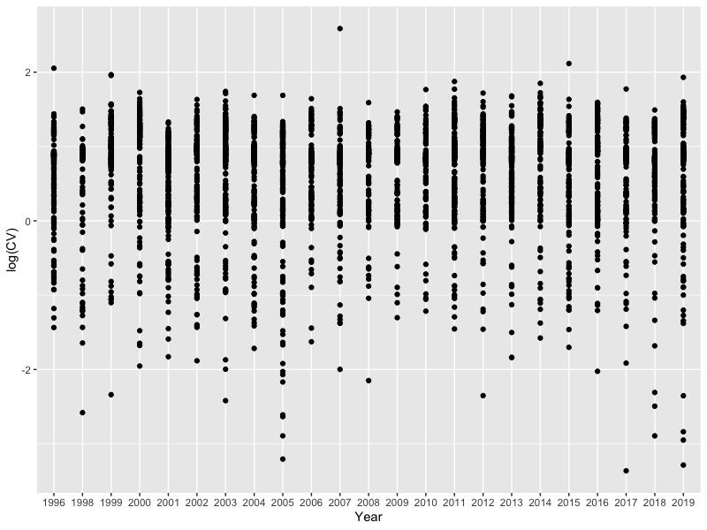

**Figure S30. Stable Precision of Abundance Estimates Over Time**

Coefficient of variation of model estimates of abundance over time. We observe no evidence of change in precision over time.